Kagame heading for a landslide win in Rwanda, observers say
by Josh Kron
10 August 2010

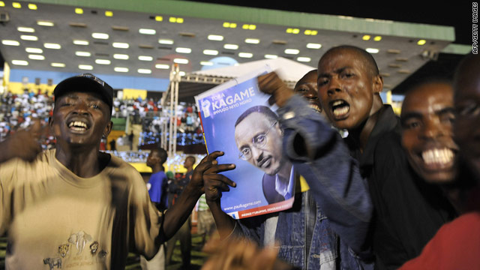
Supporters of President Paul Kagame celebrate at a rally in Kigali on Tuesday.
Kigali, Rwanda (CNN) -- President Paul Kagame is poised to win another seven-year term by a landslide in Rwanda's elections, electoral observers said Tuesday.
The observers said the voting was peaceful and "largely accurate."
Kagame, who first took power on 1994 after the genocide of 800,000 Tutsis and moderate Hutus, won an overwhelming 92.9 percent of the votes counted so far in one-third of the districts.
Kagame welcomed the results at a massive party thrown at the national stadium in the capital of Kigali Tuesday. Free drinks were handed out to thousands of supporters who danced to a host of live musicians.
"This is your victory, this is a victory for all Rwandans," Kagame said during the celebration speech, in vernacular Kinyarwanda. "Our development depends on you."
Results from the rest of the country have not yet been released, but observers said Monday's turnout was huge.
Human rights groups had expressed concern over violence and repression leading up to the vote but Salim Ahmed Salim, chairman of the Commonwealth Observation Group, lauded the polling as transparent.
"Elections in Rwanda were conducted in a peaceful atmosphere," Salim said. "The count in the polling stations was transparent and conducted fairly."
But while the vote was highly organized and efficient -- thousands of people had lined up before dawn at polling stations across the country -- observers said Rwanda's democracy faces challenges that include issues of political inclusion and press freedoms.
"There was a lack of critical opposition voices," Salim said. "Each case appears to be different, but the overall impact is a concern."
Of three aspiring candidates, two are under arrest and another has fled to Europe.
Three other candidates cleared by Rwanda's electoral commission ran on platforms similar to Kagame's and praised him continuously throughout their campaigns.
The only representatives at many polling stations were members of the ruling party, observers said.
"That frankly disappointed us," said Salim, though he placed responsibility on the opposition parties. "This right is a key transparency issue."
In Rwanda's 100-day genocide, militias made up of ethnic Hutus slaughtered ethnic Tutsis and moderate Hutus nationwide. The killing ended when Tutsi-led militias backing Kagame ousted the Hutu government supporting the massacre.
In the aftermath, Kagame transformed his country, turning it into one of the fastest growing nations in Africa and -- in the view of some -- a model of economic and social development.
Kagame's administration has mixed patriotic rhetoric with strict rules in an attempt to recreate society, and recently changed the official language for schools to English, rather than French.
"Liberation is a process," said Tito Rutaremara, the chairman of the Kagame's party, the Rwandan Patriotic Front, and also the country's ombudsman. "We want to create the nation."
Copyright 2010. All rights reserved.

