Rwanda: President Kagame Accuses West of Hypocrisy
By Henry Mukasa, New Vision
9 April 2012
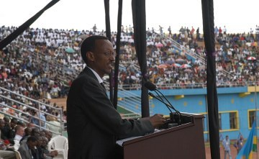
President Paul Kagame of Rwanda speaking at the anniversary commemoration of the 1994 genocide.(File Photo) (Photo Courtesy Government of Rwanda)
Kigali — Rwandan President Paul Kagame has accused Western governments of hypocrisy for preaching justice to least developed countries while harbouring and funding persons accused of committing genocide in Rwanda.
During a solemn ceremony to commemorate 18-years since the 1994 genocide that targeted the Tutsi and moderate Hutus, Kagame lashed out at the "so called free nations" for exercising double standards.
Over 800,000 people are saying to have perished when the interahamwe militias visited mayhem on Kigali using machetes, guns, clubs and sexual violence.
"As we remember those who were killed, those who killed them are walking free in some capitals of the so called free world.
There's little effort to arrest them and when it happens it's a token meant to blind us and they are released shortly," Kagame told thousands of Rwandans assembled at Amahoro Stadium in Kigali on Saturday afternoon.
"Yet when terrorist acts are committed to their people the whole world is mobilized or sometimes forced to search for those criminals to be brought to justice. It would appear that Rwandan lives or similarly African lives are less valued than their citizens," he added.
How the genocide happened
Between April and June 1994, an estimated 800,000 Rwandans were killed in the space of 100 days. Most of the dead were Tutsis - and most of those who perpetrated the violence were Hutus.
The genocide was sparked by the death of the Rwandan President Juvenal Habyarimana, a Hutu, when his plane was shot down above Kigali airport on 6 April 1994.
A French judge has blamed current Rwandan President, Paul Kagame - at the time the leader of a Tutsi rebel group - and some of his close associates for carrying out the rocket attack.
Kagame vehemently denies this and says it was the work of Hutu extremists, in order to provide a pretext to carry out their well-laid plans to exterminate the Tutsi community.
Whoever was responsible, within hours a campaign of violence spread from the capital throughout the country, and did not subside until three months later.
But the death of the president was by no means the only cause of Africa's largest genocide in modern times.
Copyright © 2012 New Vision. All rights reserved. Distributed by AllAfrica Global Media (allAfrica.com).

