May 26, 2008

Mbeki Calls Harm to Migrants a Disgrace
By BARRY BEARAK
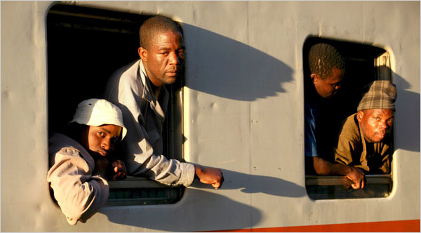
Pedro Sá da Bandeira/European Pressphoto Agency
Mozambicans returned Sunday from Johannesburg. Anti-immigrant violence that began in the city has killed 50 people.
JOHANNESBURG — After two weeks of only faint and infrequent condemnations of the anti-immigrant violence that has troubled South Africa, President Thabo Mbeki on Sunday described the wave of xenophobic attacks as an “absolute disgrace” that has blemished the country’s reputation.
“Never since the birth of our democracy have we witnessed such callousness,” he said in a 10-minute nationally televised speech.
The president spoke after being roundly excoriated as lacking leadership during the mayhem that has left 50 people dead.
A leading newspaper here, The Sunday Times, called for his resignation in a front-page editorial on Sunday. “Throughout this crisis — arguably the most grave, dark and repulsive moment in the life of our young nation — Mbeki has demonstrated that he no longer has the heart to lead,” it said.
The newspaper faulted him for leaving the country as the violence raged and for not visiting any of the squatter settlements where the attacks had occurred. “Mr. President, it is clear you have lost interest in governing the Republic,” it said. “We appeal to you: Stand down in the interests of your country.”
A week earlier, Mathews Phosa, the treasurer-general of Mr. Mbeki’s party, the African National Congress, called for him to cut short his term, due to end next April, saying he had “lost touch” with the party’s mainstream.
Others in the A.N.C. hierarchy quickly said that the comment represented the views of an individual and not the party. But even for a lame duck, Mr. Mbeki has been in an extremely weakened position since he suffered a humiliating defeat in December, losing a vote for the party’s top job to Jacob Zuma, whom he fired as South Africa’s deputy president in 2005.
On Sunday, Mr. Zuma, presumed to be Mr. Mbeki’s successor, met with crowds east of Johannesburg where the violence has been severe.
In contrast, Mr. Mbeki made his prerecorded speech from a plush red upholstered chair, using the monotones and scholarly diction for which he is known.
“Whatever concerns that exist, including those about housing, jobs and so on,” he said, “this can and must be addressed in a manner consistent with the dignified, humane and caring characteristics that define the majority of our people, not through criminal means.”
Sporadic attacks on foreigners have occurred in South Africa for years, but two weeks ago assaults on immigrants in Alexandra, a township near the center of Johannesburg, quickly spread to other parts of the metropolitan area. In one attack in a squatter camp, photographers recorded a man being burned alive, an image that shamed much of the nation.
Though the violence in Johannesburg has slowed, the attacks have spread to other cities, including Durban and Cape Town. About 30,000 foreigners have fled their homes, seeking shelter in police stations and churches as the winter cold descends. Thousands of the despairing have left South Africa to return to Zimbabwe, Mozambique, Malawi and other nations.
Most immigrants remain, however. South Africa, which accounts for a third of sub-Saharan Africa’s economic output, is home to an estimated five million foreigners. Many of them compete for jobs at the lower rungs. Amid high unemployment, woeful housing and rising prices in South Africa, outsiders are often made into scapegoats, the local poor focusing their resentments on the immigrant poor.
But there is dissatisfaction with the government, too. Mr. Mbeki took office in 1999 after a landslide victory, succeeding Nelson Mandela. And while he lacked his predecessor’s charisma, he seemed a calm, cerebral steward who was well respected if not deeply beloved.
Under Mr. Mbeki, the nation has had the longest period of sustained economic growth in its history. He was re-elected by a huge majority in 2004.
But the economic progress is unequally shared, bringing far more benefits to a small portion of the nation’s black citizens, the well connected and the highly skilled. Desmond Tutu, the retired Anglican archbishop and Nobel laureate, warned in 2004: “At the moment, too many of our people live in grueling, demeaning, dehumanizing poverty. We are sitting on a powder keg.”
The violence against immigrants seems to be a lighted fuse attached to that keg. It has happened as Mr. Mbeki has suffered so many setbacks that his legacy seems to be collapsing.
Besides his loss to Mr. Zuma, he has been tarnished by allegations that he sought to shield his police commissioner from corruption charges. He also has steadfastly refused to publicly criticize President Robert Mugabe of Zimbabwe, whose policies have led that nation into economic chaos and caused some three million people to flood into South Africa.
The sustained economic growth Mr. Mbeki so proudly achieved is now endangered by a shortage of electricity that has forced industry to reduce production. By Mr. Mbeki’s admission, the government did not heed the warnings of experts that new power stations were required.
But last week, as the criticism of Mr. Mbeki was in crescendo, one of his top aides, the Rev. Frank Chikane, complained about the unfairness of blaming one person for a rash of woes. “It is a cop-out in a democracy to blame the president only for what goes wrong,” he said.
Copyright 2008 The New York Times Company

