Uganda Ingrid Turinawe 'sexual abuse' protesters strip

By BBC News

23 April 2012
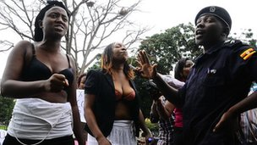
Credit: BBC News
Six protesters were arrested and later detained.

A group of women have stripped to their bras in protest at the alleged sexual assault by Ugandan police of a high-profile female opposition politician.
Footage shows an officer squeezing the breast of Ingrid Turinawe of the Forum for Democratic Change (FDC) during her arrest ahead of a rally last week.
Deputy police chief Andrew Kaweesa has apologised, saying the incident will be investigated.
Uganda's opposition says police regularly harass them during protests.
Since President Yoweri Museveni's controversial 2011 re-election, there has been a wave of opposition demonstrations - many of which have ended in violence and arrests.

“How would you feel if we squeezed your balls?”
End Quote Protesters' placard
But correspondents say Ugandans are outraged by the arrest on Friday of Ms Turinawe, who is the head of the Women's League of the FDC led by Kizza Besigye.
Ugandan television footage clearly shows that, as several officers tried to pull her out of her vehicle, another grabbed and squeezed her breast - and she is heard shouting out in pain.
The BBC's Siraj Kalyango in the capital, Kampala, says a group of about 15 women marched through the town to the main police station waving placards, including one that read "How would you feel if we squeezed your balls?"
Six protesters were arrested after they refused to put their tops back on - but they were released two hours later without charge.
"We wanted to ask the police if they are there to do their jobs or there to pinch breasts," event organiser Barbara Allimadi told the AFP news agency.
Copyright 2012 BBC News

