November 02, 2009 “Somalia plane hijack bid foiled”

Monday, 2 November 2009
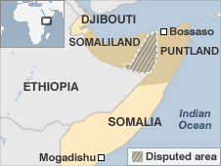
Two men have been arrested in Somalia after an aircraft was hijacked, officials in north of the country say.
Two men armed with pistols boarded the plane bound for Djibouti at an airport in Bossaso, in the semi-autonomous region of Puntland.
Half-way through the flight the plane turned back to Bossaso.
Puntland Security Minister Mohammed Said Samata said Somali forces opened fire on the hijackers as soon as the plane landed, wounding one of them.
Several of the airport employees responsible for searching the passengers have also been arrested

Copyright 2009 The British Broadcasting Company

