Somalia 09-11-03 “Pirates clash with Somali militia over captive British couple”
Militia commander claims his group fought abducters as they were due to hand British couple over to extremists
- Matthew Weaver and agencies
- guardian.co.uk, Tuesday 3 November 2009 07.52 GMT
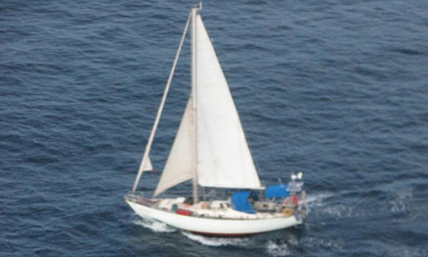
Peter and Rachel Chandler's yacht the Lynn Rival in a picture released by the EU Naval Force Somalia. Photograph: EU Navfor/PA
Fears were growing today for a British couple seized by Somali pirates after reports that they have become the subject of a battle for control between rival gangs.
A Somali clan elder claimed clashes took place over plans by one faction of the pirate gang to transfer Paul and Rachel Chandler to a militant Islamist group.
The land battle took place after the couple had been brought ashore, Hussein Mohamed Kahiye, a clan elder in the central Somali village of Bahdo, told the Associated Press.
He said: "We did not want the pirates to use our territory to hold hostages or hand them over to another group. We took up arms with the help of (the moderate Islamic group) Ahlu Sunna Waljama and opposed [the other group]." He said the couple were not injured in the fighting.
According to Kahiye, the Chandlers had been held on a ship at sea, but were now in coastal areas and travelling in two minibuses and an all-terrain vehicle.
A pirate claiming to speak on behalf of the group holding the couple told the BBC on Saturday that they wanted a $7m (£4.2m) ransom. The Foreign Office said the government would not make any "substantive concessions to hostage-takers, and that includes the payment of ransom".
The Chandlers were heading for Tanzania in their yacht, the Lynn Rival, when a distress signal was sent on 23 October . They were forced to sail towards Somalia before being moved onto a container ship, the Kota Wajar, which was seized by the pirates last month. The British navy found their empty yacht last Thursday.
Rachel Chandler broke down in tears during her first contact after being taken hostage by Somali pirates.
In an interview with ITV News on Friday, she urged her family not to worry, saying she and her husband were "safe" and described their captors as "very hospitable people".
Rachel Chandler's brother, Stephen Collett, made a direct appeal to the pirates to release the couple.
"My sister and her husband are blameless tourists and if you release them it would show your compassionate nature and it would be positive to everyone. Thank you," he said.
Copyright 2009 The Guardian Comapany

