May 20, 2008

South Africans Take Out Rage on Immigrants
By BARRY BEARAK and CELIA W. DUGGER
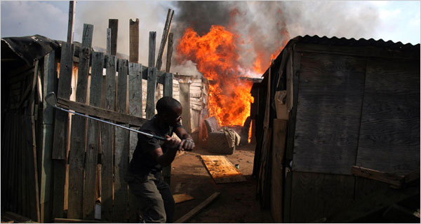
Joao Silva for The New York Times
A man demolished a shack to stop a fire from spreading on Monday in Ramaphosa, a settlement near Johannesburg where six immigrants have been killed
Correction Appended
JOHANNESBURG — The man certainly looked dead, lying motionless in the dust of the squatter camp. His body seemed almost like a bottle that had been turned on its side, spilling blood. His pants were red with the moisture.
Nearby was evidence of what he had endured. A large rock had been used to gouge his torso. Embers remained from a fire that had been part of some torture. Shards of a burned jacket still clung to the victim’s left forearm.
Then, as people stepped closer, there was the faintest of breath pushing against his chest. “This guy may be alive,” someone surmised. As if to confirm it, the man moved the fingers of his right hand.
The jaded crowd neither rejoiced nor lamented. After all, the horrific attacks against immigrants around Johannesburg had already been going on for a week, and in their eyes the victim was just some Malawian or Zimbabwean, another casualty in the continuing purge.
This nation is undergoing a spasm of xenophobia, with poor South Africans taking out their rage on the poor foreigners living in their midst. At least 22 people had been killed by Monday in the unrelenting mayhem, the police said.
But the death toll only hints at the consequences. Thousands of immigrants have been scattered from their tumbledown homes. They now crowd the police stations and community centers of Johannesburg, some with the few possessions they could carry before mobs ransacked their hovels, most with nothing but the clothes they wore as they escaped.
“They came at night, trying to kill us, with people pointing out, ‘this one is a foreigner and this one is not,’ ” said Charles Mannyike, 28, an immigrant from Mozambique. “It was a very cruel and ugly hatred.”
Xenophobic violence, once an occasional malady around Johannesburg, is now a contagion, skipping from one area to another. The city has no shortage of neighborhoods where the poor cobble together shacks from corrugated metal and wood planks.
Since the end of apartheid, a small percentage of the nation’s black population — the highly skilled and the politically connected — has thrived. But the gap between the rich and poor has widened. The official rate of unemployment is 23 percent. Housing remains a deplorable problem.
“That’s fueling the rage at the bottom,” said Marius Root, a researcher at the South African Institute of Race Relations. “There’s the perception that they’re not enjoying the fruits of the liberation.”
Here at the Ramaphosa Settlement Camp, the squatter’s colony southeast of the city, six immigrants have been killed in the past two days — or perhaps seven if the man found in the dust Monday morning does not survive.
“We want all these foreigners to go back to their own lands,” said Thapelo Mgoqi, who considers himself a leader in Ramaphosa. “We waited for our government to do something about these people. But they did nothing and so now we are doing it ourselves, and we will not be stopped.”
A familiar litany of complaints against foreigners are passionately, if not always rationally, argued: They commit crimes. They undercut wages. They hold jobs that others deserve.
George Booysen said that as a born-again Christian he did not believe in killing. Still, something had to be done about these unwanted immigrants.
They are bad people, he said: “A South African may take your cellphone, but he won’t kill you. A foreigner will take your phone and kill you.”
Beyond that, he said, immigrants were too easy to exploit.
“White people hire the foreigners because they work hard and they do it for less money,” Mr. Booysen said. “A South African demands his rights and will go on strike. Foreigners are afraid.”
These days, the nights and early mornings belong to Ramaphosa’s marauders. On Monday, soon after dawn, they were boldly celebrating their victories. Stores belonging to immigrants already had been looted, but there were still fires to set and walls to overturn. There was dancing and some singing.
Then the police arrived, quick to fire rubber-tipped bullets. Rocks were tossed by the mob in counterattack, but in order to triumph they really only had to be patient. The police did not stay long. They could not keep up with the widespread frenzy.
Those left behind by the nation’s post-apartheid economy commonly blame those left even further behind, the powerless making scapegoats of the defenseless.
South Africa has 48 million people. It is hard to find a reliable estimate of the number of foreigners in the mix. Most certainly, not all immigrants push ahead of South Africans economically. But Somalis and Ethiopians have proved themselves successful shopkeepers in the townships.
Zimbabweans, who make up this country’s largest immigrant group, benefited from a strong educational system before their homeland plunged into collapse, sending an estimated three million across the border to seek refuge here. Schoolteachers and other professionals — their salaries rendered worthless by Zimbabwe’s hyperinflation — come to work as housekeepers and menial laborers.
Many South Africans consider themselves at a disadvantage with employers. “If you have a surname like mine, you can’t get a job,” said Samantha DuPlessis, 23, a woman of mixed race. “I’ve been looking for a job for four years. All the employers want to hire foreigners.”
So there is a nationalistic sense of jubilation in the areas where the immigrants have been dislodged. “The Maputos, we don’t want them around anymore and we’ll never have to worry about them again,” said Benjamin Matlala, 27, using a common term for people from Mozambique.
Mr. Matlala, who is unemployed, lives in Primrose, a community now emptied of its foreigners. The sections they lived in are being dismantled. First, the belongings of the fleeing immigrants were looted.
On Monday, the dwellings themselves were torn apart by dozens of eager men. It wasn’t difficult. Walls of thin metal were knocked over with a few blows. Wooden posts were pulled from the ground. Picture frames were tossed into a heap of rubbish.
Mr. Matlala had managed to get a shopping cart, which he filled with scrap metal. Each load, he said, would fetch 40 rand in trade, or about $5. He was hoping for three loads, more money than he had made in a long time.
This article has been revised to reflect the following correction:
Correction: May 21, 2008
A front-page picture caption on Tuesday about xenophobic rioting in South Africa showed a man demolishing a shack in Ramaphosa, a settlement near Johannesburg where six immigrants have been killed. Because of an editing error, the caption may have left the mistaken impression that the man was a rioter, and should have made clear he was trying to prevent the spread of a fire.

Copyright 2008 The New York Times Company

