Gran, worker killed on smallholding
by Marietie Louw-Carstens, Beeld
May 6, 2011

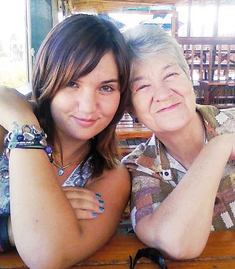
Antjie Parkin, 70, in a photograph with her granddaughter Anel Wessels, 18. (Beeld)

Johannesburg - The badly-beaten bodies of a 70-year-old grandmother and an employee have been found on a smallholding in the Lephalale (Ellisras) region in Limpopo.
Antjie Parkin's body was discovered in her house on Tuesday, while the blood-covered body of Thomas Tshabalala, 45, who had worked for her son, Ben Wessels, for several years, was found by trackers under debris on the banks of the Mogol River.
Parkin lived in a house close to her son and daughter-in-law on the smallholding about 40km from Lephalale. She was alone during the day when her family went to work.
Annelie Wessels, Parkin’s daughter-in-law, said on Thursday that her husband had found his mother’s body on Tuesday afternoon.
He came home between 16:00 and 17:00 and went to the main bedroom of their home, where he smelled something like an electrical fire. “He thought he had forgotten to switch off the electric blanket. Then he saw the angle grinder next to the bed. The safe was open.”
The angle grinder was used to cut open the safe. A firearm was stolen from it.
Beaten beyond recognition
Wessels immediately ran to his mother’s house and found her on the carpet of her bedroom.
"She was beaten beyond all recognition and the strangulation marks on her neck were clearly visible. No one should have to see their mother like that,” Annelie said.
The police were called while the family wondered where Tshabalala was. His body was only found later that night.
"His head was bashed in and he was strangled. He was also stabbed with a knife,” said Annelie.
According to a statement by TAU-SA North, a tracking team found “the tracks of the social terrorist” about 10km from Lephalale.
"South Africa is falling into a maze of blood, power and hate,” read the statement.
It looked like the murderer was picked up by someone in a car.
By late on Thursday night no one had been arrested.
Parkin will be buried on Tuesday. She is survived by her two sons, daughters-in-law and six grandchildren.
No funeral arrangements have been made yet for Tshabalala.

Copyright 2011 Beeld

