Face-off at Free State University
by News24
17 August 2011
Video - Face-off at Free State University

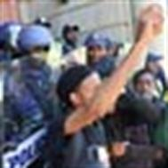
News24 User, Lee-Anne Kotze sent us this video of the chaos that broke out at the University of the Free State's Bloemfontein campus where police had to intervene between students and protesters - believed to be mostly ANCYL members. WATCH

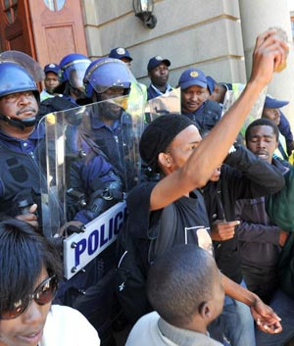
Riot police are seen on the University of the Free State campus where a protest got out of hand. (Theo Jeptha, Volksblad)
Bloemfontein - Chaos broke out at the University of the Free State's Bloemfontein campus on Wednesday, after about 800 people - believed to be mostly ANCYL members - stormed the main building.
The group, who had been bussed in to the campus, protested against the fact that no political activities by outside groups will be allowed on the campus during the university's SRC elections.
They also demanded that the rector, Professor Jonathan Jansen, be fired.
Free State chair of Sasco (SA Student Congress) Manyene Lesapo said: "He [Jansen] has burned political structures on campus."
Calling him a "coconut", they bemoaned the fact that they had co-operated with him in the past.
Police intervened when white students and protesters, armed with sticks and stones and singing Kill the boer, faced off over pamphlets that the group had scattered all over the campus.
The white students were stopped from cleaning up the pamphlets strewn in front of the main building.
Free State ANC Youth League chair, Kgotso Morapela, leading the protest, at one stage had to calm a small group of protesters after being interrupted with "Ag shurrup" (Oh shut up), shouted by a student looking on.
Moments before the interruption, Morapela acknowledged the protest was illegal.
Thuggish behaviour
Jansen said the university was worried about "thuggish behaviour" by outside groups invading the campus.
"An urgent interdict has been obtained and any further invasions by outside groups will lead to arrest."
Dean of students Rudi Buys said the election for a student representative council continues.
Buys said lectures were not interrupted by the fracas.
"Everything continues as normal."
The university said police had arrested about 150 people.
Approached for comment, two students said they were not sure what was going on.
"Those people, we do not know them," they said, adding "They do not belong here."
They felt the new SRC election process had been "fine" and "fair".
Another student felt Jansen had done his best to get rid of racism and sort out "political activism".
He said before Jansen arrived there was constant trouble at Kovsies.
“Now these things happen. This is tragic,” he said, adding that he did not know any of the protesters.
Copyright 2011 News24.

