ANCYL to appeal hate speech ruling
by SAPA
14 September 2011
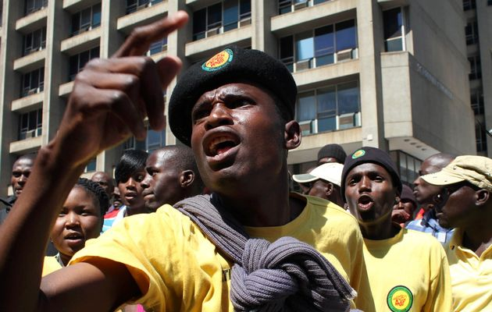
Supporters of ANC Youth League leader Julius Malema. Image by: STR / Reuters

The ANCYL will appeal against a ruling that the song "awudubule ibhunu" (shoot the boer) is hate speech, secretary-general Sindiso Magaqa says.
The judgment favoured a minority in the country, he told reporters in Johannesburg on Wednesday.
"The minorities continue to control South African courts and control South Africa's majority."
Magaqa said the league intended taking the matter all the way to the Constitutional Court to have the anti-apartheid song unbanned.
Afriforum Youth laid a civil complaint with the Equality Court against league president Julius Malema for singing the words, saying they made minorities and farmers feel threatened.
Judge Colin Lamont ruled on Monday that the song constituted hate speech.
Copyright 2011 SAPA

