South African Official Barred
By Devon Maylie, The Wall Street Journal
11 november 2011
JOHANNESBURG—A firebrand politician, who advocated nationalizing South Africa's mines and taking back white-owned farmland, was ousted on Thursday from the country's ruling party, dealing a severe blow to a leader who has shaped the political discourse of Africa's biggest economy.
Julius Malema was suspended for five years from the African National Congress, after being found guilty of bringing the party into disrepute and sowing divisions. He was found not guilty of a third charge of racism and political intolerance.
The decision came after more than two months of inner-party deliberations. The hearings were set in motion back in July, when Mr. Malema and other youth leaders were charged with encouraging regime change in Botswana – a stable and prosperous democracy. The youth league described Botswana's government policy decisions as embracing "imperialism and a potential security threat to the entire African continent," causing embarrassment among South African officials and tensions with its smaller neighbor.
Derek Hanekom, chairman of the ANC disciplinary committee, called the charges "very serious" and said they had "damaged the integrity of the ANC and South Africa's international reputation," undermining its ability to attract foreign investment.
Another ANC Youth League leader, spokesman Floyd Shivambu, was suspended for three years for bringing the party into disrepute and misconduct, including vulgar language used in a conversation with a journalist. Both Messrs. Malema and Shivambu have the right to appeal to appeal these verdicts.
Even in ridding the ruling party of its most radical elements, the ANC and South Africa face a bumpy ride ahead. Factions within the party – including some aligned with Mr. Malema – have fought over how to create jobs and generate wealth in order to help shrink a huge black underclass that poses a growing threat to the country's social stability.
Those party divisions aren't likely to disappear with Mr. Malema out of the picture. "Just because the more heated voices in this policy discussion have been removed doesn't mean that the discussion doesn't happen," said Jeff Gable, an analyst at Absa Capital. "But it does mean the tone of that debate can be a little more measured."
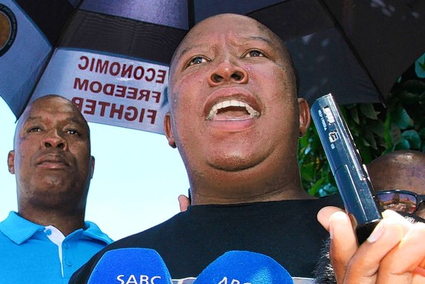
Reuters
South Africa has paid a hefty price for its political infighting. At a time when the African continent is looking more attractive to investors, given the troubles in Europe and the U.S., South Africa has struggled to attract foreign capital. Last year, foreign direct investment in South Africa fell to $1.5 billion, a quarter of the 2009 level, according to the United Nations Conference on Trade and Development.
On Wednesday, Moody's Investors Service Inc. cut its outlook on the debt in South Africa citing concerns the government may not be able to meet budget targets due to "popular pressures and rising internal strains."
The high number of young people without work – making up most of the nation's 25% unemployment rate – have largely supported Mr. Malema's brand of populism. Mr. Malema has sought to use the grievances of the black underclass to challenge South Africa's business leaders, who are still predominantly white, and government officials, who were seen as too cautious in pursuing radical economic change.
In addition to calls to nationalize at least 60% of the mines in one of the world's most mineral-rich countries, Mr. Malema has offered other controversial proposals. Those include taking land away from white owners without compensation because it was seen as stolen in the first place. He also wanted the government to have substantial stakes in the nation's banks and to exercise more control of South Africa's often-critical media.
In drumming up support for these positions, Mr. Malema hasn't been shy about flexing his political muscle. At the end of October Mr. Malema and the ANC Youth League led a march demanding nationalization and economic wealth redistribution, leading roughly 5,000 marchers from the mine body in the country to the national stock exchange to deliver memorandums laying out the changes the youth league wants.
In August, youth-league supporters gathered outside ANC headquarters to protest the disciplinary process imposed upon Mr. Malema and his colleagues. Protesters threw stones at police, attacked journalists and held-up anti-Zuma placards.
ANC leaders say he too frequently crossed a line between the party's tradition of bold, militant leadership and ill-discipline.
It was the second time in 18 months that Mr. Malema was charged with brining the party into disrepute, with the first case ending in a demand that Mr. Malema apologize for his remarks and attend anger-management classes.
The decision to suspend South Africa's powerful youth leader is seen as a victory for President Jacob Zuma, who has been criticized for being weak and indecisive when faced against Mr. Malema's more forceful policy calls.
But it also creates a politically volatile situation if Mr. Zuma, as expected, seeks a second term head of the African National Congress at a party conclave next year. Many of the same young members who had supported Mr. Zuma's bid to oust his predecessor, former South African president Thabo Mbeki, have now turned against him.
Up until now, Mr. Malema's proclamations have gone unchecked -- publicly at least -- by Mr. Zuma. The government has said repeatedly that mine nationalization isn't policy but that it would be researched and debated within the ruling party.
Mr. Zuma appointed a research committee at the start of the year to look at how best to transform the mining industry. The committee's research will be presented at an important party-policy conference in 2012 where the ANC is supposed to make a decision on the issue.
"The ANC can't abandon the research into nationalization, but it will occur in a different climate," says Prince Mashele, the executive director of Pretoria-based think tank Centre for Politics and Research. "It won't be as energetic and there is more room for sobriety."
—Patrick McGroarty contributed to this article.
Copyright 2011 Down Jones & Company

