Malema won't go
By SAPA, Sowetan Live
16 February 2012

ANC Youth League president Julius Malema will not be removed from his position by anyone but the structures of the league, his deputy Ronald Lamola said.
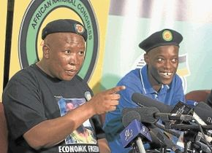
ON APPEAL: ANC Youth League president Julius Malema and secretary general Sindiso Magaqa Photo: PUXLEY MAKGATHO
"It is only the internal process of the ANCYL that can decide to elect or un-elect leadership of the ANCYL," Lamola told reporters at Luthuli House in Johannesburg.
"The ANCYL will never agree that its leadership be subjected to unfair and unjust treatment or banished for narrow political purposes."
At the ANCYL's lekgotla last week, Malema said he would resign as the organisation's president if the structures of league said he should.
"All leaders of regional, provincial and national executive committees... across the country rejected the offer of ANCYL president to resign his position," said Lamola.
He said the ANCYL's leadership would remain in place until June 2014, when its next elective conference would be held.
copyright Sowetan LIVE. © Avusa Limited. All Rights Reserved.

