Hate speech complaint laid against Zuma
By SAPA
24 February 2012

Rightwing group the Gelofte Volk laid a complaint of hate speech against President Jacob Zuma at the Human Rights Commission in Johannesburg on Friday.
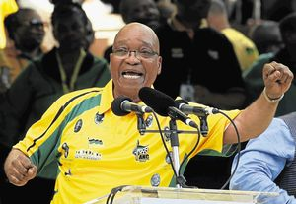
File photo of President Jacob Zuma's speech during the ANC's centenary celebrations in Bloemfontein.
Photograph by: REUTERS
Gelofte Volk leader Andre Visagie said he presented the charges "on behalf of the Boer nation".
The first charge was for Zuma's singing "the forbidden song", "dubul' ibhunu" (shoot the boer) at the African National Congress's centenary celebrations in Bloemfontein on January 11.
The second was against the ministry of police for allegedly failing to intervene at the trial of Afrikaner Weerstandsbeweging (AWB) leader Eugene Terre'blanche's killers, when black people held up signs saying "boere word gebleksem" (sic).
The third charge related to the ANC government's "failure" to employ a special force to protect farmers after the dissolution of military commandos.
The ANC government also discriminated against the Boer youth "in that they are deliberately excluded from employment in the government [and] private sector", Visagie said.
"Now they are punished for 'apartheid' because they have a white skin."
The presidency earlier said it was unaware of the complaint by the fringe group.
Spokesman Mac Maharaj said: "I am sure that [the HRC] will attend to it through the proper procedures".
He said the presidency would not be sending someone to hear the complaint on Friday.
Visagie said he hoped the case would draw international media attention because "we are killed in this country just because we have white skins".
The Gelofte Volk (People of the Covenant) was founded by Visagie, the AWB's former general secretary.
About 15 of the group's supporters, most of them middle-aged women, gathered outside the commission's offices before the complaint was heard.
They held up the Vierkleur flag, symbol of the Afrikaner far right, and a placard that read "stop die plaasmoorde" (stop farm murders).
Andries Terre'blanche, brother of Eugene, joined Visagie and the leadership of the Volk to lay the complaint.
Copyright 2012 SAPA

