Probe call over Sri Lanka killings
Al Jazeera
3 September 2009

A top UN investigator has called for a full international investigation into whether Sri Lankan soldiers killed captured and unarmed Tamil rebels in violation of international law.
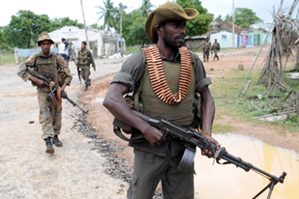
A UN rapporteur says an investigation is needed into allegations of extrajudicial killings by the army [EPA]

The call, from the UN's special rapporteur on extrajudicial, summary or arbitrary executions, follows the circulation of mobile phone video footage apparently showing Sri Lankan forces executing a group of unarmed rebels.
Speaking to Al Jazeera in New York, Philip Alston said the weight of evidence apparently shown in the video demanded a full investigation.
"Whenever a government is presented with an allegation of this gravity, the obligation is to carry out or to allow others to carry out a full investigation," he said.
"The only group that has the resources is the government - it can of course work through others, but it has to get involved."
On Wednesday the US ambassador to the UN added Washington's concerns over the video.
"These reports are very disturbing, they are of grave concern," Susan Rice told reporters.
"We'd like more information as we formulate our own national response."
'Fake video'
The Sri Lankan government has dismissed the video as fake and denied its forces carried out abuses.
Previous attempts at the UN to formally raise the issue of Sri Lanka's conduct during its final offensive against the Tamil Tiger rebels met resistance from Russia and China.
Both countries rejected calls for official Security Council discussions, saying the was an internal matter for the Sri Lankan government.
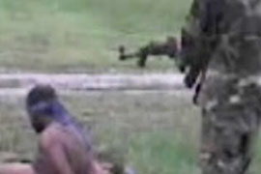
Sri Lanka's government has rejected
the video saying it is fake
The video of the shootings, first aired last week on British television last week, shows government forces executing unarmed, naked, bound and blindfolded Tamils during the military's final on the Tamil Tiger rebels earlier this year.
The video originated from a group calling itself Journalists for Democracy in Sri Lanka.
Ban Ki-moon, the UN secretary-general, has not called for an investigation, although a spokeswoman indicated on Monday that he was taking the issue seriously.
"We have always viewed with utmost concern the reports and information received from various sources of serious human rights violations, including those related to war crimes," Marie Okabe told reporters.
James Ross, legal and policy director for Human Rights Watch told Al Jazeera that more must be done to find the truth behind the video and the extent of alleged abuses.
"The video is disturbing and makes clear we need an independent international inquiry into not only this incident, but also into the violation of human rights in the final months of the fighting that took place on both sides," he said.
Source: | Al Jazeera and agencies

