Sri Lanka’s Ghosts of War

By Namini Wijedasa, The New York Times

30 December 2011
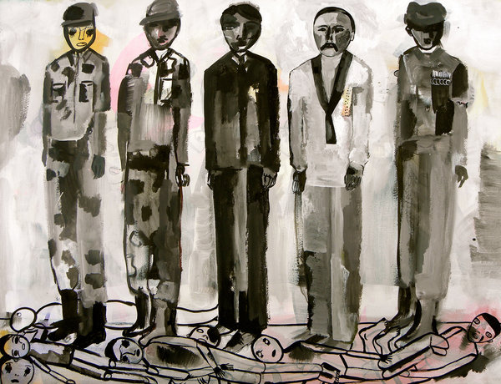
Credit: Karen Barbour

THE Sri Lankan government’s defeat of the separatist Tamil Tigers in 2009 ended a three-decade war that took tens of thousands of lives. But only now is the government beginning to acknowledge its huge human cost. Two weeks ago, a government-appointed reconciliation commission released a long-awaited report, giving voice to the war’s civilian victims for the first time.
From August 2010 to January 2011, hundreds of people appeared before the commission in tears, begging for news of their loved ones, many of whom had last been seen in the custody of security forces. A doctor spoke of how they managed to survive under deplorable conditions in places “littered with dead bodies and carcasses of dying animals.”
In October, I visited a rural school just 6 miles from Mullivaikkal, on the northeast coast of the island, where the army finally crushed the Tigers — an area still off-limits to civilians. The government says there are too many land mines to allow resettlement; critics say there are too many bodies in mass graves.
The classroom had a new roof, but more than two years after the war ended, its walls were still pockmarked with shrapnel, a window was shattered and the floor was cracked. Most students’ uniforms were discolored; many wore flip-flops and carried tattered bags. A 7-year-old with a deep scar across his back stared at me. A shell had landed while his family slept and his sister was killed, he told me in a thin voice.
One child after another spoke of injuries and deaths caused by shelling; of lingering wounds; of forced conscription by the Tigers; of poor widowed mothers; and of family members missing after being taken into state custody.
Since Sri Lanka’s independence from Britain in 1948, members of the island’s Tamil minority have insisted that they face linguistic, educational and employment discrimination from the Sinhalese majority, which controls the government.
The Tigers — a sophisticated, well-financed guerilla group that formed in 1976 and pioneered the technique of suicide bombing — sought to redress their grievances by violent means, with the goal of establishing an independent Tamil state. They routinely recruited child soldiers, killed Tamil dissenters and massacred Sinhalese and Muslims. In 1991, the group went so far as to assassinate the Indian prime minister, Rajiv Gandhi, for having sent Indian troops to Sri Lanka in 1987 to enforce a peace accord. The Tigers held out against the Sri Lankan military until they were decisively defeated in May 2009.
Some journalists called Sri Lanka’s final battle with the Tigers a “war without witnesses.” Aid workers were asked to withdraw from the conflict zone months before the government defeated the Tigers. Only handpicked reporters, mostly from state media, were allowed to embed with troops. Those journalists knew what they must not write, for fear of losing access. The others relied on organized tours that were meticulously choreographed by the army — producing sanitized war coverage with the gory bits tucked away. As a result, there was no outside scrutiny of the controversial war.
But that did not mean there were no witnesses. As the army attacked, hundreds of thousands of civilians were trapped in between. They were the Tigers’ “human shield,” and a source for forced conscripts, including children. They were also witnesses.
More than 950 people testified before the commission and nearly 5,000 submitted written statements. Survivors spoke of displacement, incessant shelling and morbid fear. The commission’s report depicts a country where the rule of law is crumbling and where abductions, enforced or involuntary disappearances, protracted detention without charge and attacks on journalists continue. It proposes depoliticizing the police, disarming illegal armed groups and allowing a more independent media.
While the commission makes sensible recommendations and exposes grave atrocities committed by the Tigers against ordinary people, it also demonstrates that government troops shelled no-fire zones in order to neutralize rebel attacks from within.
The report is a valuable document, but regarding the war’s terrible final weeks, it is largely an apologia for the army. The commission admits only that “civilian casualties had in fact occurred in the course of cross-fire,” and blames the Tigers for most of them. The commission asserts that the government was confronted with an unprecedented situation — a massive human shield — that left it no other choice but to respond as it did.
However, on three separate occasions the government declared no-fire zones, giving the illusion of safety to hundreds of thousands of terrified civilians who fled into them. The rebels also went in, set up their heavy weapons among innocent men, women and children and proceeded to attack the military with gusto. The army retaliated and large numbers of civilians were killed.
Sri Lankans no longer need to pretend that the army didn’t shell zones where civilians were encouraged to gather, or subscribe to the fantasy that no innocents died when shells landed on or near hospitals.
If Sri Lanka wants true reconciliation, simply blaming the Tigers is not enough. The government, and the country, must take responsibility for the dead, mend the lives of the survivors — whatever their ethnicity — and stop the vicious cycle of ethnic strife by arriving at a political solution that meets, if not all aspirations, most of them. Until then, the end of the war will not bring true peace.
Namini Wijedasa is a journalist.
Copyright 2011 The New York Times

