Sri Lankan army agrees to probe war crimes

By The Telegraph

15 February 2012

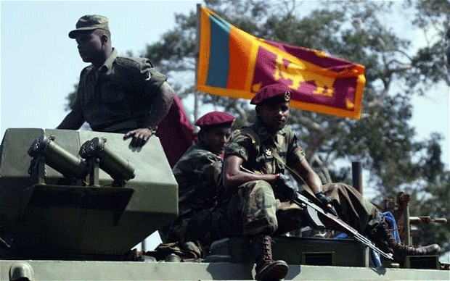
Credit: AP
Sri Lanka's Killing Fields examined the atrocities committed during the country's civil war.

Army chief Jagath Jayasuriya appointed a court of inquiry to investigate charges that troops were responsible for killing civilians and prisoners in the final stages of their war against Tamil rebels in 2009, an army statement said.
The dramatic U-turn from the security establishment came two days after the United States warned that the Indian Ocean island would face censure at next month's UN Human Rights Council meeting in Geneva.
Lieutenant General Jayasuriya asked a five-member panel of officers to investigate allegations against the force, including that it executed prisoners as claimed in a documentary by Britain's Channel 4 television channel.
The probe is a major shift for Sri Lanka's armed forces, which had insisted that it did not kill a single civilian while crushing the separatist Tamil Tiger rebels in a no-holds-barred offensive that ended in May 2009.
The army said the inquiry was ordered after the government's own Lessons Learnt and Reconciliation Commission (LLRC), a panel which probed why a 2002 truce collapsed, said civilians had died as a result of military action.
"If there is a prima facie case disclosed against any person from the evidence led before the Court of Inquiry, a General Court Martial will be convened to try the alleged offenders," the army said.
It said an inquiry into observations of the LLRC and the "Channel 4 video footage irrespective of its authenticity or otherwise, is now in full progress."
Human rights groups have said up to 40,000 civilians were killed in the final months of the government's military campaign.
The LLRC in a 400-page report to President Mahinda Rajapakse, who made it public in December, noted that civilians were killed while hospitals were shelled by troops, but added that attacks may not have been intentional.
The LLRC also made sweeping recommendations urging Rajapakse to ensure greater media freedom, improve governance and withdraw the military from civilian duties in the former war zones where minority Tamils are concentrated.
International rights groups refused to testify before the LLRC, which comprised retired senior government officials, saying the process was flawed at every level.
However, Britain and the US have welcomed the recommendations of the LLRC and have urged Sri Lanka's government to fully implement its recommendations, including a call for an independent probe into alleged war crimes.
Human Rights Watch said it hoped the announcement by Sri Lanka would be "meaningful and not just a stunt to prevent a resolution against Sri Lanka next month at the UN Human Rights Council."
"If there is action, it has to encompass not only rank-and-file soldiers but senior officials responsible for giving the orders and creating the policies that led to so many deaths and injuries," the group's Asia Director Brad Adams said.
However, he cautioned that there had been many promises which never led to any tangible action in the past.
"We'll believe they are serious about accountability when we see people charged for the very serious abuses in the final stages of the war," Adams told AFP.
The UN estimates some 100,000 people perished during Sri Lanka's 37-year ethnic conflict which ended with the wiping out of the entire military leadership of the Liberation Tigers of Tamil Eelam.
Source: AFP
Copyright 2012 The Telegraph Media Group Ltd.

