Sri Lanka reacts to the UN: Nationalists do protest

By The Economist
27 March 2012
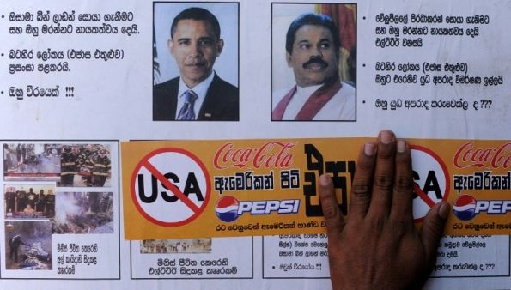
Credit: AFP
“HILLARY CLINTON is naked! Obama is naked!” shriek the Sinhala-language graffiti across a wall in Colombo. Following their government’s lead, many Sri Lankans are reacting angrily to the passage of an American-led initiative in the UN Human Rights Council which seeks reconciliation and accountability for war crimes that are alleged to have been committed at the end of their state’s civil war against the Tamil Tigers.

Three decades of war ended in 2009 with a bloody climax that left thousands of civilians dead and the Tigers defeated. Rights groups now want the government to account for the civilians who were killed by the army and to investigate allegations of serious war crimes that have been levelled against its soldiers. Having gained the UN’s support, the activists now face the wrath of a nationalistic public.
A very different group of critics say that the resolution, which was passed by a clear majority on March 22nd, was so watered down that it bordered on the blasé. But Mahinda Rajapaksa, Sri Lanka’s president, is bristling. Speaking at a function in a remote village on March 24th, he insisted that Sri Lanka will not tolerate “arbitrary interference” in its affairs.
So no deal, and no compromise. That was the position Sri Lanka took at the Geneva-based council, explained G.L. Peiris, the external affairs minister. Addressing a crowded press conference on March 26th, he blamed India squarely for having swayed the council in favour of the resolution.
Manmohan Singh, India’s prime minister, had announced two-and-a-half days before the final session that his government was “inclined to vote” for the resolution. His statement was swiftly circulated among the council’s members. Several among them who would have opposed the initiative consequently chose to vote for it or to abstain, Mr Peiris said.
Some analysts in Colombo saw this as an admission of just how influential India has become in shaping international opinion on South Asian issues. Others felt the Sri Lankan government was fumbling around for a scapegoat.
The real trouble was that India had said initially that it would oppose the resolution. Things changed after a senior member of the Sri Lankan delegation indiscreetly announced India’s position to the press. Major political parties in the South Indian state of Tamil Nadu, which claim to share an affinity with the Tamil population in Sri Lanka, then combined forces to demand a policy reversal.
After weeks of relentless haranguing from their coalition partners, India’s central government backtracked. Mr Peiris says this came as a “shock”. Hours before the vote, however, India’s diplomats negotiated with America to dilute the draft’s language. That intervention however, did not earn India any kudos with its neighbour to the south. Instead, Sri Lanka’s media is accusing the Indians of duplicity.
Sri Lanka’s political relations with India will weather this storm. As Basil Rajapaksa, the powerful economic development minister and the president’s brother conceded, “We will never forget our relationship with India”. By contrast, China—which voted against the resolution and denounced it for good measure—is being praised generously.
Sri Lanka’s strained ties with the West will undoubtedly get worse, not least because the resolution is regarded here as a hostile move. Western diplomats prefer to characterise it as a means of pressing the Rajapaksas’ lethargic government into keeping promises it has made in the name of accountability and reconciliation.
America’s initiative was co-sponsored by 40 countries. (Among them was Norway, which once attempted—and failed—to negotiate a permanent peace between the Sri Lankan government and Tamil Tiger rebels.) Among other things, its language urges Sri Lanka to implement the recommendations of a presidential commission that tried, ineffectually, to unravel the confusion of the war’s final stages.
The conclusions of the Lessons Learnt and Reconciliation Commission (LLRC) are widely regarded as being inadequate, when it comes to the task of fact-finding. Still its report offered other proposals to solve the country’s longstanding ethnic grievances. For instance, it called for devolution of power and a rapid demilitarisation of the island’s north and east, where large numbers of the Tamil minority live. The government has so far resisted both.
Even before the dispute at the Human Rights Council, Sri Lanka was shifting its foreign policy emphasis to Asia, Africa and Latin America. As a part of this change, several of its diplomatic missions in Europe are to be closed down even as more are opened on other continents.
The government is seething that the West will not let up on demands for accountability. It sees these as being motivated by the pro-Tamil Tiger diaspora. During the weeks that preceded the resolution’s passage, government ministers went so far as to accuse America and its allies of conspiring to topple the regime.
The same sycophants warned that their heroic president was on the verge of being hauled up before an international war-crimes tribunal, though in fact he never was. Crowds protested outside Western diplomatic missions, burning effigies and jeering. One minister called for a boycott of all American products, including Google, Coca-Cola and McDonald’s.
It is grimly ironic that there is still no discussion on the contents or aims of the resolution. For its part, the government seems to be growing ever more belligerent. Nimal Siripala de Silva, a senior minister, said on March 27th that the commission had “gone beyond its mandate” and that careful consideration would be given before its proposals were implemented.
For months, the government had flaunted the very fact of the LLRC as a means of fending off international calls for a war-crimes investigation. Now it is questioning the commission’s own report. This is precisely what independent analysts had feared would happen. But at least Sri Lanka is officially under watch—if only overseas.
Copyright 2012 The Economist

