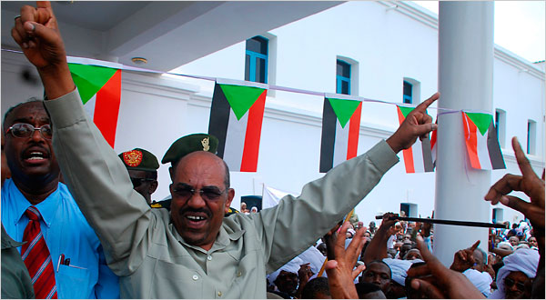
Mohamed Nureldin/Reuters
President Omar Hassan al-Bashir in Khartoum, Sudan, on Sunday at a protest against the International Criminal Court.
Sudan Leader Charged With Genocide
By MARLISE SIMONS and JEFFREY GETTLEMAN
July 15, 2008 The New York Times
THE HAGUE, Netherlands (AP) -- The prosecutor of the International Criminal Court filed genocide charges Monday against Sudanese President Omar al-Bashir, accusing him of masterminding attempts to wipe out African tribes in Darfur with a campaign of murder, rape and deportation.
The filing marked the first time prosecutors at the world's first permanent, global war crimes court have issued charges against a sitting head of state.
Luis Moreno-Ocampo asked a three-judge panel at the International Criminal Court to issue an arrest warrant for Al-Bashir to prevent more deaths. Some 2.5 million people have been forced from their homes in Darfur and are still under attack from government-backed janjaweed militia.
"Genocide is a crime of intention -- we don't need to wait until these 2.5 million die," he said in an interview with The Associated Press.
Moreno-Ocampo was undeterred by concern that his indictment against al-Bashir might lead to vengeance against Darfur refugees and the closing of Sudan's doors to relief agencies and possibly peacekeeping troops.
"The genocide is ongoing," he said, saying that systematic rape was a key element of the campaign. "Seventy-year-old women, 6-year-old girls are raped," he said.
Moreno-Ocampo filed 10 charges against al-Bashir: three counts of genocide, five of crimes against humanity and two of murder. Judges are expected to take months to study the evidence before deciding whether to order al-Bashir's arrest.
Despite the charges, al-Bashir is unlikely to be sent to The Hague any time soon. Sudan rejects the court's jurisdiction and refuses to arrest suspects.
Moreno-Ocampo's decision to go after al-Bashir is expected to cause further turmoil in Sudan and some analysts fear it could make life even worse for refugees living in Darfur's sprawling camps and reliant on humanitarian aid for food and water.
Moreno-Ocampo said most members of the Fur, Masalit and Zaghawa ethnic African groups were driven from their homes by Sudanese forces and the janjaweed in 2004. Since then, the janjaweed have been targeting the camps aiming to starve the refugees.
"They (al-Bashir's forces) don't need gas chambers because the desert will kill them," he said, drawing a comparison to Nazi Germany's notorious method of mass murder during the Holocaust.
The refugees "have no more water, no more food, no more cattle. They have lost everything. They live because international humanitarian organizations are providing food for them," he said.
An estimated 300,000 people have died in Darfur since conflict erupted there in 2003 when local tribes took up arms against Al-Bashir's Arab-dominated government in the capital, Khartoum, accusing authorities of years of neglect.
Moreno-Ocampo said the international community needs to act to prevent more deaths. "We are dealing with a genocide. Is it easy to stop? No. Do we need to stop? Yes. Do we have to stop? Yes," he told AP.
"The international community failed in the past, failed to stop Rwanda genocide, failed to stop Balkans crimes," he said. "So this time the new thing is there is a court, an independent court ... saying 'this is a genocide."'
In an indication of the fury that could be unleashed if Omar al-Bashir is charged with orchestrating a five-year reign of terror in Darfur, his ruling National Congress Party on Sunday warned of "more violence and blood" in the vast western region if an arrest warrant is issued against the president, state TV reported.
There are also fears the fresh Darfur case could spark a backlash against the 9,000-strong U.N.-African Union peacekeeping force in Darfur. It was the U.N. Security Council that in March 2005 asked Moreno-Ocampo to investigate crimes in Darfur.
Moreno-Ocampo said any attacks on peacekeepers would be "further evidence that he's committing genocide -- attacking those that like to protect these people. It's confirming he is committing genocide."
A spokeswoman for the force said it had not suspended any military operations. "All essential peacekeeping operations are being carried-out by troops," Shereen Zorba said in an e-mail from Khartoum.
However, she said: "a limited number of operations that carry security risk to civilian staff are temporarily restricted."
Indicting a sitting president is not unprecedented.
Other international courts previously have indicted Serb leader Slobodan Milosevic and Charles Taylor of Liberia while they were in office. Milosevic died in custody in The Hague in 2006 shortly before the end of his trial, while Taylor is on trial in a courtroom just four stories above the room where Moreno-Ocampo made his announcement Monday for orchestrating atrocities in Sierra Leone.

Copyright 2008 The New York Times Company

