July 24, 2008

Sudanese Leader Mounts Charm Offensive
By JEFFREY GETTLEMAN
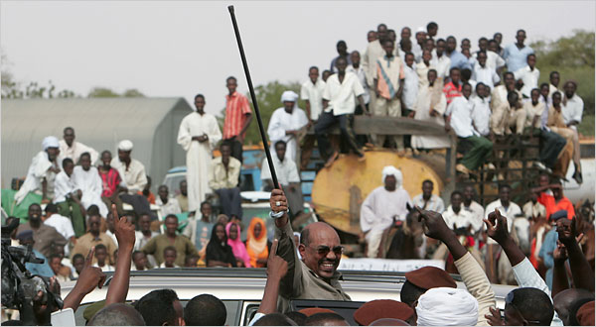
Khaled Desouki/Agence France-Presse — Getty Images
Sudanese President Omar Hassan al-Bashir during his tour in El-Fasher, north Darfur, on Wednesday.
EL FASHER, Sudan — Omar Hassan al-Bashir, the president of Sudan, who has been accused of genocide, is not especially well known for his dance moves.
But on Wednesday, in front of tens of thousands of people packed into what appeared to be a mandatory pep rally in Darfur, the portly president jumped on a desk and did a little jig. He jutted his cane. He rolled his hips. Shadows of sweat bloomed under his arms. But the crowd did not seem to care.
“Seer, seer, al-Bashir!” spectators screamed. “Go, go, Mr. Bashir!”
With an international indictment looming on charges of genocide, Mr. Bashir returned to the scene of the war crimes he is accused of committing in Darfur — this time on an uncharacteristic charm offensive.
It was here in El Fasher, on the same airport tarmac where Mr. Bashir was blessed Wednesday morning by a hundred elders leaning on canes, that rebels blew up government planes in 2003, setting off a conflict that would claim 300,000 lives and threaten to destabilize an entire region in the heart of Africa.
Sudanese forces and government-sponsored militias swept the countryside. They burned down villages, raped countless women and drove hundreds of thousands of people off their land, all part of an effort to put down the rebellion. The violence drove more than two million people off their land. The prosecutor for the International Criminal Court, Luis Moreno-Ocampo, has accused Mr. Bashir of being the “mastermind” of this strategy, the one with “absolute control.”
But on Wednesday, Mr. Bashir did not act as if he felt guilty. He focused on peace, development and pleasing the crowds. The minute he stepped off the plane here, a white dove was thrust into his hands.
Mr. Bashir threw the bird toward the sky. It flapped its wings a few times, but did not really fly.
No bother. Mr. Bashir beamed and strutted down the runway.
The roadshow, part of a whistle-stop tour of the three biggest cities in Darfur, seems to be part of his attempt to head off an arrest warrant that the prosecution is seeking and judges in The Hague are considering.
The United Nations Security Council may suspend the case, and some Council members, like China and Russia, have already indicated that they are leaning this way, saying the allegations against Mr. Bashir are complicating peace efforts. It seems that Sudan’s government hopes that if it shows some good will the United Nations will intervene.
Mr. Bashir was not especially antagonistic at the rally on Wednesday, for instance, and did not rail about evil America. He did not mention any Zionist conspiracies. The approach was a change for a head of state who had threatened not so long ago to mount a jihad against United Nations peacekeepers and turn Darfur into a “graveyard” of blue helmets. Thousands of peacekeepers are now here and more on their way as part of a United Nations-African Union force.
Instead, Mr. Bashir visited their headquarters in El Fasher, expressing condolences for the peacekeepers who had been killed and pledging cooperation with their mission, the joint force said. “You are our guests and our partners,” the peacekeepers quoted him as saying.
Mr. Bashir’s new strategy seems to be to portray himself and his government as victims, not aggressors.
“Whenever we take one step forward toward peace, our outside enemies pull us back,” he said. He also admitted that “there had been problems in Darfur and injustices,” which was unusual for him.
“And we’re working on them,” he reassured his people.
He talked of all the wells he would drill and schools he would build and how he would reach out to rebel groups to stabilize the war-ravaged region in western Sudan.
“We are with you, Darfur!” Mr. Bashir said.
The event was carefully orchestrated, as government rallies often are in Sudan, and choreographed, down to the dances the women did for Mr. Bashir.
The heat was stupefying, maybe 110 degrees. Two elderly women fainted while Mr. Bashir, 64, was dancing. Still, it was harder to find a Bashir detractor than a patch of shade. “If Bashir is so bad, how could he have been president for 19 years?” Asia Ibrahim, a woman in the crowd, asked, offering the self-serving logic of a government widely accused of being a dictatorship.
The crowd was packed with turbaned elders, schoolgirls in camouflage uniforms, boys on donkeys, men on camels with faces wrapped against the desert dust, cracking whips in the air. Soldiers in green uniforms, red uniforms, blue uniforms, brown uniforms made sure everyone was appropriately cheerful.
Clearly, Mr. Bashir was saying the right things, though he was short on specifics and his track record is highly suspect.
“It was vaguely positive,” said a Western diplomat who traveled with Mr. Bashir. “He’s not nearly as confrontational as he has been. But the question is: where’s the substance?”
Copyright 2008 The New York Times Company

