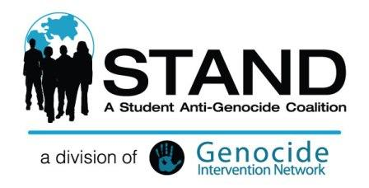
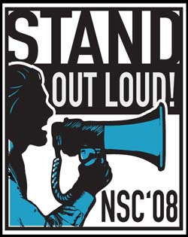
I’m excited to announce that registration is now open for the STAND National Student Conference 2008: STAND Out Loud! The Conference will take place in Washington, DC November 7-9, less than a week after the elections, a perfect time to make an important statement to the new administration.
This year’s conference has something new for everyone! Learn about the atrocities in Burma and the Democratic Republic of the Congo, and get in-depth updates on the current situation on the ground in Sudan from policy experts. Discover what all of these conflicts have in common and how you can apply the skills that you’ve developed fighting the genocide in Darfur to fight injustice around the world. Get ready to make your chapter multi-conflict so that we can advocate for an end to genocide not just in Darfur, but wherever and whenever it may occur.
Our brand new activist workshops will equip you with the tools it takes to stop genocide! Brainstorm cool fundraising events for your chapter after hearing about new, sophisticated fundraising tactics to raise money for your chapter and civilian protection in our first ever development workshop. Find out how to use the new STAND website straight from one of its creators and how to use other online tools in a brand-new web workshop. Network with other STAND chapters while learning new advocacy tools in our new-and-improved Advocacy and Media workshops!
This is a conference you won’t want to miss, but spots will fill up quickly, so register now! Check the STAND Blog or the Conference Facebook Group for frequent updates on the conference – from speakers, to new workshops, to info about a rally in front of the President-Elect’s transition headquarters!
If you’re an adult, you can participate too! That same weekend, the Save Darfur Coalition will be holding a conference for adult activists, and Tents of Hope will be hosting a major event on the National Mall that we’ll attend together as a national coalition of STAND students!
Got questions? Email your Outreach Coordinator!
I hope to see you there in November!
-Nick Gaw
Student Director, Swarthmore College, '09

