Khartoum denies arming militias
BBC News
13 August 2009
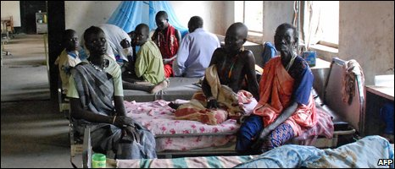
People hurt in the attack continue to recover in Akobo's hospital
Officials in the north of Sudan have rejected accusations they armed militias who killed dozens in recent ethnic clashes in the south.
Humanitarian minister Abdelbagi Gailani described the clashes as a "war between tribes" and said Khartoum was committed to stopping the violence.
At least 185 Lou Nuer people were killed in Jonglei state when reportedly attacked by Murle fighters last week.
Several hundred people have died in such clashes this year.
The UN says this is more than in Sudan's Darfur conflict.
What is going on now in the south is a war between tribes
Abdelbagi Gailani
Humanitarian minister

Violence over land and cattle in South Sudan is exacerbated by a ready supply of firearms following the 22-year civil war between north and south, which ended in 2005.
Commanders in South Sudan's army accused the north of arming the militias.
But Mr Gailani told the BBC's Network Africa programme there was no logic in the allegations.
"This is politics. What is going on now in the south is a war between tribes [that has been] continuing for quite a good [long] time," he said.
"You can easily accuse and make allegations against people. The weapons are available in the area. We have to stop it by all means."
Officials in Jonglei state said members of the Lou Nuer community had gone fishing south of Akobo town amid a severe food shortage when they were attacked.
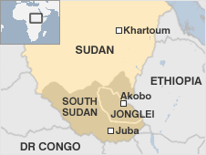
Eleven South Sudanese soldiers, who were guarding their camp, were among those killed.
Analysts say the violence comes at a critical time for Sudan, as tensions grow in the north-south unity government.
Elections are due in April 2010, the first chance to vote for many in decades.
After that, a 2011 independence referendum is due for the south, which many believe will see Africa's biggest nation split fully in two.
Copyright 2009 BBC News

