Two Years to Self Destruct in Sudan

It's not too late to stop Africa's largest country from splitting in half. But Obama needs to act now to prevent the worst.

BY JOHN NORRIS | SEPTEMBER 1, 2009
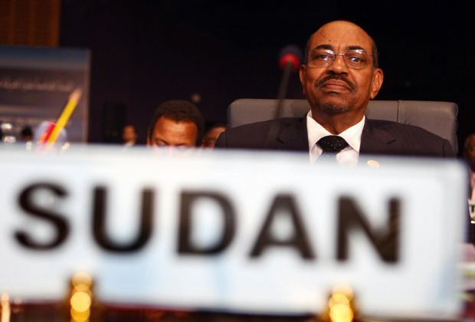
CRIS BOURONCLE/AFP/Getty Images
Imagine if we had enjoyed the luxury of knowing, two years before it happened, that Yugoslavia would disintegrate in 1991. Or just think if U.S. diplomats had been able to predict years earlier exactly when the Soviet Union was going to collapse. One certainly hopes the United States would have been better positioned to deal with these momentous events. But a current case gives one pause. Sudan might very well split in half in precisely two years, and policymakers have taken far too little notice.
In 2011, Sudan is scheduled to hold a referendum that will allow South Sudan to vote on severing its ties with the North and declaring independence. Almost every observer has concluded that if this referendum happens, the South will vote overwhelmingly for independence, sundering in half the largest country in Africa (that's why the road ahead could not be clearer). But it's the actions taken now, by the Barack Obama administration, that may well determine if Sudan's breakup occurs peacefully or is steeped in blood and a return to full-blown civil war.
The early signs are discouraging. There has been a sharp uptick in violent clashes in South Sudan of the same sort that have already killed hundreds this year. So dramatic is the escalation that the United Nations recently noted that the violence there is now worse than that in Darfur. There have been abundant allegations that the Sudanese government, headed by President Omar Hassan al-Bashir (who is still wanted on outstanding war crimes charges by the International Criminal Court), has been rapidly rearming proxy militias in the South to do Khartoum's bidding. The use of proxy militias has long been a favorite tactic of the ruling party -- both in Darfur and South Sudan. Officials from the South accuse Khartoum of distributing "thousands" of AK-47s in recent months. The U.N. special rapporteur for human rights in Sudan has also noted the presence of more modern and powerful weaponry in recent clashes than has traditionally been the case.
Foreign proxies are also up to no good. The notorious Lord's Resistance Army (LRA), originally from Uganda, has stepped up its attacks in South Sudan. Bashir has a long history of using the LRA as his cat's paw in exchange for weapons, money, and political support. And though it's too early to tell if he is doing so again, Khartoum certainly does have every incentive to use violence in an effort to derail the independence referendum -- or at least seize substantial chunks of territory (some of which is oil-laden) from a newly independent South.
The response from the international community to these dark storm clouds on the horizon has largely amounted to whistling past the graveyard. The U.S. special envoy for Sudan, Maj. Gen. J. Scott Gration, set off a firestorm of protest in testimony before the Senate Foreign Relations Committee on July 30 when he suggested that Sudan only remained on the list of state sponsors of terrorism for purely "political" reasons and that some of the sanctions against Sudan might need to be rolled back. The administration quickly swept into damage-control mode, insisting that Sudan's removal from the terrorism list was not being contemplated as part of its Sudan policy review and that the special envoy was only referring to lifting some specific sanctions that he thought were obstructing the delivery of aid and development to South Sudan. (If that were the case, Gration's position was seriously undercut when the government of South Sudan announced that it opposes lifting any sanctions against the North.)
©2009 Washingtonpost.Newsweek Interactive, LLC. All rights reserved.

