Deaths in South Sudan tribal clash
Al Jazeera News
6 September 2009
At least 25 people have been killed, including a tribal chief, his three wives and several children, while dozens have been wounded, in clashes in a southern Sudan village, the South Sudan army has said.
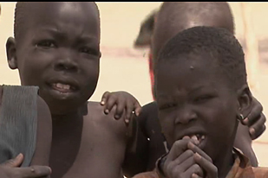
Tribal disputes caused by cattle rustling and long-running feuds have displaced 250,000 people

Some 50 armed and masked men in military uniform from the Shilluk tribe attacked the village of Bony-Thiang in Upper Nile state on Friday morning, killing civilians of the Dinka tribe, the army said on Saturday.
Dinka fighters mounted a retaliatory attack on a nearby Shilluk village on Buol on Saturday morning, killing at least five, Kuol Diem Kuol, an army spokesman, said.
The incidents were the latest in a rising wave of tribal violence in South Sudan that has killed more than 2,000 people, including many women and children, and displaced another 250,000, according to the UN.
Fears
Rival tribes from Sudan's underdeveloped south have clashed for years in disputes often caused by cattle rustling and long-running feuds, but violence has soared this year.
The United Nations said the attacks could mar preparations for Sudan's for national and presidential elections due in April 2010.
Lise Grady, a UN Humanitarian Coordinator for southern Sudan, told Al Jazeera that “The area was not previously affected by the food crisis or inter-tribal violence and it’s not inconceivable that this is a politically motivated attack linked to the upcoming elections."
The elections are required under the 2005 peace deal that ended the north-south civil war.
Sudan is also scheduled to hold a referendum in January 2011 on whether South Sudan should become independent.
Source: | Al Jazeera and agencies

