Clooney continues push for Sudan peace
by Joseph Weber, The Washington Times
2 January 2011
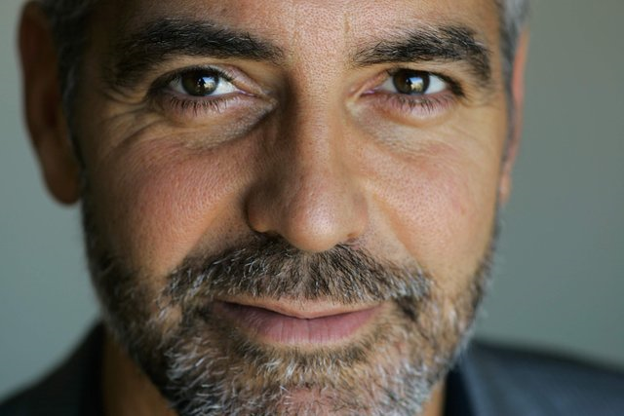
George Clooney poses for a portrait during the Toronto International Film Festival in Toronto in 2007. A group founded by American actor George Clooney said on Tuesday, Dec. 28, 2010, it has teamed up with Google, a U.N. agency and anti-genocide organizations to launch satellite surveillance of the border between north and south Sudan to try to prevent a new civil war after the south votes in a secession referendum next month. (AP Photo/Carolyn Kaster)
Hollywood actor George Clooney brought his star power to the political theater of the Sunday talks shows to continue his efforts to stop the violence in Sudan.
"We want to let potential perpetrators of genocide and other war crimes know that we're watching, the world is watching," Mr. Clooney said on ABC's "This Week."
Mr. Clooney made his plea as south Sudan is set for a referendum next month on whether to secede from north Sudan. The actor's Not on Our Watch group is helping Google, the United Nations, the human rights group Enough Project and others launch a satellite surveillance system on the north-south boarder to prevent a new civil war.
Enough Project co-founder John Prendergast said Sunday the real star in the unfolding of event is the United States.
"You know, the United States is the biggest actor in Sudan," he said. "We can have a major influence on whether or not a deal is struck. ... And we can have a major influence on whether human rights violations continue in Darfur. That's going to take presidential leadership."
This article is based in part on wire service reports. © Copyright 2011 The Washington Times, LLC. Click here for reprint permission.

