**Sudan's defense minister wanted for war crimes**

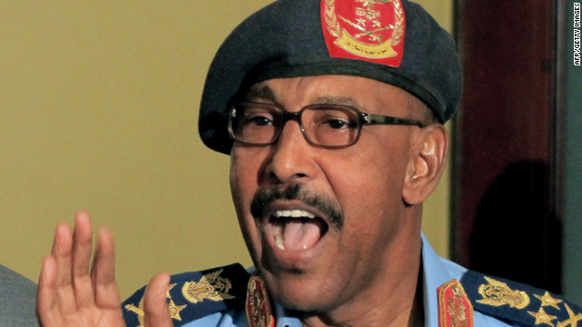By CNN

01 March 2012

The International Criminal Court has issued an arrest warrant for Sudan's defense minister for 41 counts of crimes against humanity and war crimes allegedly committed in the Darfur region.

Abdelrahim Mohamed Hussein is wanted for actions ranging from August 2003 to March 2004 in Darfur, where rebels have fought government forces and allied militiamen such as the Janjaweed since 2003.The United Nations estimates as many as 300,000 people have been killed and almost 3 million people have been displaced from their homes.

Hussein was at the time the country's interior minister "during attacks upon the towns and villages of Kodoom, Bindisi, Mukjar and Arawala in the Wadi Salih and Mukjar localities of West Darfur," the court said.

The court said "there are reasonable grounds to believe that Mr. Hussein is criminally responsible for 20 counts of crimes against humanity (persecution, murder, forcible transfer, rape, inhumane acts, imprisonment or severe deprivation of liberty and torture) and 21 counts of war crimes (murder, attacks against civilian population, destruction of property, rape, pillaging and outrage upon personal dignity)."

The court has other cases involving Darfur. Sudanese President Omar al-Bashir is wanted for war crimes, crimes against humanity and genocide. Sudanese government official Ahmad Harun, Janjaweed leader Ali Kushayb, and rebel leaders Abdallah Banda, Saleh Jerbo and Abu Garda also face war crimes charges.

However, Sudan does not recognize the court and refuses to hand over suspects.

Minister of Information Sana al-Awad said Sudan was not concerned by the arrest warrant.

"The court has become a political tool and not one that seeks justice," she said. "Sudan considers the arrest warrant an outcome of lobbying by anti-Sudan groups in the U.S. It is an unjustifiable allegation."

***CNN © 2012 Cable News Network***