April 17, 2008

Incentive in Sudan Talks: Normalized Ties With U.S.
By HELENE COOPER
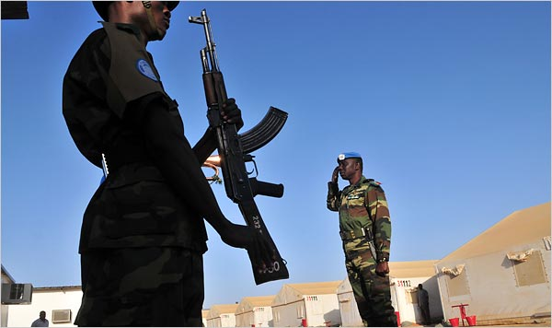
Lynsey Addario for The New York Times
A Senegalese peacekeeper did his morning salute this month at a base in Geneina, West Darfur.
WASHINGTON — The Bush administration could remove Sudan from an American list of state supporters of terrorism and normalize relations if the Sudanese government agreed, among other steps, to allow Thai and Nepalese peacekeepers in its Darfur region, says a document outlining the American negotiating position for talks with Sudan that began Wednesday.
The document was part of a series of negotiating papers exchanged between the governments in preparation for talks in Rome. They were provided to The New York Times by an American government official critical of the administration’s position.
Sudan has already promised to let United Nations peacekeepers operate within its borders, and human rights advocates and others say it would be a mistake for the United States to offer any new incentives until Sudan carries out that and other pledges.
“Given the fact that Khartoum has been involved in negotiations repeatedly over the years regarding Darfur and the comprehensive peace agreements and has signed documents and consistently failed to implement what they’ve signed, why are we discussing normalization with them?” said Roger Winter, a former Sudan negotiator at the State Department. Richard Williamson, the United States envoy to Sudan, is in Rome for the talks with Sudanese officials. The broad thrust of the American position has been known, but the negotiating papers provide new details about the positions staked out by each side as they try to resolve differences over Darfur.
At least 200,000 people have been killed there since the Arab-dominated government of Sudan unleashed tribal militias known as the janjaweed on non-Arab rebel groups and civilians.
The papers show that the United States is demanding that Sudan speed up visas for humanitarian workers and allow private aid organizations to work in Darfur.
Sudan wants an end to economic sanctions imposed by the United States since 1997. Sudan complained in the negotiating papers that sanctions had continued “despite the many positive achievements” by its government in Khartoum.
In addition, Sudan wants United States backing for its membership in the World Trade Organization, American support for the cancellation of Sudan’s foreign debts and “the immediate release of the Sudanese detainees at Guantánamo.”
Sudan is further seeking a formal apology for the Clinton administration-era strike on the Shifa pharmaceutical plant in Khartoum. It was destroyed by American cruise missiles in 1998 in the days after the terrorist attacks on the American Embassies in Kenya and Tanzania.
American officials have acknowledged over the years that the evidence that prompted President Clinton to order the missile strike was not as solid as first portrayed, and have said that there was no proof that the plant had been linked to Osama bin Laden, a resident of Khartoum in the 1980s. But the United States has not ruled out the possibility that the plant did have some link to chemical weapons production.
Bush administration officials have acknowledged in the past that they have offered to restore full diplomatic ties, lift economic sanctions and remove Sudan from the American list of state sponsors of terrorism in exchange for concessions on Darfur.
The Sudanese government says the death toll in Darfur has been exaggerated, and has denied an accusation from President Bush that the killing there amounts to genocide.
The Sudanese government has signed several peace agreements relating to Darfur or another internal conflict, in the non-Arab southern part of Sudan. But international aid organizations and American officials say that Sudan has failed to carry through on the promises it made in those agreements.
Sudanese Army bombs and new attacks by Arab militias in the ravaged western region of Darfur have driven thousands of refugees into neighboring Chad, according to the United Nations. In the oil-rich region of Abyei, which is claimed by both the government of Sudan and the semiautonomous government of South Sudan, several hundred people have died in recent clashes between a large group of Arab nomads, the Misseriya, and South Sudan’s armed forces. Like the janjaweed militias, the Misseriya are armed by Sudan’s government.
Sudan, pressed by the Bush administration, signed a comprehensive peace agreement with the South in 2005, but President Omar Hassan al-Bashir has balked at carrying out major parts of the deal.
“We see this process of potential improvement in the United States/Sudan relationship as a holistic one, covering the entirety of Sudan,” said the text of the American negotiating document.
Sudanese officials, meanwhile, adopted a besieged air in their negotiating paper, complaining that the Darfur government had “suffered the brunt of many punitive measures which were either totally unjustified and/or politically motivated.”

Copyright 2008 The New York Times Company

