March 2, 2008
Op-Ed Columnist

Africa’s Next Slaughter

By NICHOLAS D. KRISTOF
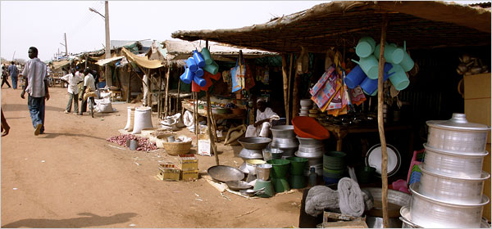
Naka Nathaniel/The New York Times
A market in Abyei that has been blockaded.
ABYEI, Sudan
This dusty little town of rutted dirt streets is surrounded by janjaweed, Arab militias armed by the Sudanese government and paid to do its dirty work.
But this isn’t Darfur, where the janjaweed have played the central role in the genocide that has claimed hundreds of thousands of lives. Rather, Abyei is on the edge of southern Sudan, in a region that is supposed to be at peace.
In the 1980s and 1990s, it was here that the government perfected the techniques that later became notorious in Darfur: mass rape and murder by armed militias, so as to terrorize civilians and drive them away. Now Sudan is coming full circle, apparently preparing to apply the same techniques again to Abyei and parts of the south.
With international attention distracted by Darfur and the United States presidential race, the Sudanese government now is chipping away at the 2005 peace treaty that ended the north-south war in Sudan. If war erupts, as many expect, the flash point will probably be here in Abyei, where the northern government is pumping oil from wells it refuses to give up.
“War is going to take place,” Joseph Dut Paguot, the acting government administrator in the Abyei region, said bluntly.
Chol Changath Chol, a representative of South Sudan in Abyei, agreed: “If there are no changes, war will come. It will break out here and spread everywhere.”
Since late November, there have been repeated clashes in the Abyei area between South Sudan’s armed forces and a large tribe of Arab nomads, the Misseriya, which is armed and backed by the Sudanese government in Khartoum. Mr. Paguot said that several hundred people had been killed in these clashes, and that some of the gunmen were government soldiers who had taken off their uniforms to masquerade as tribal fighters.
On Feb. 7, gunmen from the Misseriya shot up and looted a bus arriving in Abyei and began blockading the road that leads into the town from the north. That has cut off supplies, so shops in the town market are running out of fuel and food, and prices are rising.
“It is reaching a critical point for the poor,” said Jason Matus, a United Nations official in Abyei.
A group of Misseriya has appointed officials to create their own government for Abyei and has threatened to march in with thousands of armed men to install it. This is almost exactly the same approach that President Omar al-Bashir has taken in Darfur: arm the janjaweed and unleash them on a black African population, then dismiss the slaughter as just “tribal fighting.”
Mr. Paguot said that 16,000 militia members were gathered on the north side of Abyei, backed by a few tanks and many pickup trucks with mounted machine guns, ready to invade. They aren’t called the janjaweed, but it’s the same idea.
Some local officials and Misseriya elders have worked heroically to avert violence, but state-controlled newspapers in Khartoum are carrying false reports of attacks on Arabs, inflaming tensions.
In the 2005 peace agreement that ended 20 years of war between North and South Sudan, both sides agreed to accept the “final and binding” ruling of the Abyei Boundary Commission. But President Bashir has rejected the findings because they would mean giving up oil wells.
The agreement came about because of tireless diplomacy by the Bush administration, but since then Washington has dropped the ball. It is still possible to avert a new slaughter here, but only if there is a major international effort — involving the United Nations, Egypt, China and Europe as well as the United States — to ensure that the peace agreement is followed and that President Bashir will pay a price for attacking the south.
A crucial step would be for China to suspend transfers of arms to Sudan until the Khartoum government works for peace with the south and in Darfur. Unfortunately, China refuses to take that step.
Mr. Bashir’s plan seems to be to encourage Arab nomads to drive out other ethnic groups from areas with oil. Then once fighting begins, he would have an excuse to cancel national elections next year — which he would almost surely lose — and he might be able to rally Sudanese Arabs behind him in a nationalist campaign to hold on to the oil fields.
So remember this little town of Abyei. It’s the tinderbox for Africa’s next war, which will probably resemble Darfur but be carried out on a much wider scale.
“If there is just one bullet in Abyei,” said Col. Valentino Tocmac, the commander of the south’s forces here, “that will be the end of the peace.”
Comment on this column on my blog at: www.nytimes.com/ontheground.
Copyright 2008 The New York Times Company

