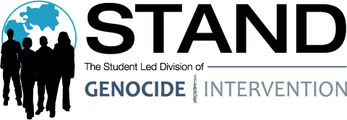

Check out the video to hear more about recent developments in Sudan and opportunities for you to take action:
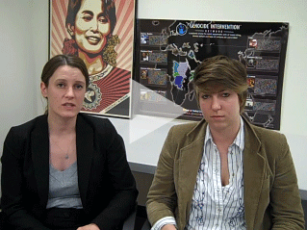
The world's eyes are turned to Sudan in this critical moment. There's a lot of concern that violent conflict may be around the corner, depending on what actions the parties in Sudan take in the weeks and months ahead.
Sign up for our March in-district lobby days. Congress goes on recess March 29th, providing us with the perfect opportunity to talk with our representatives about genocide prevention and what Congress can do with regards to Sudan. Participating could not be easier. If you sign up, we'll schedule your meeting, provide you with training calls and resources, and find others to attend the meeting with you.
We also put together some FAQs on the elections, so look them over and contact your Outreach Coordinator if you have any further questions.
In Peace,
Jenna Fox
STAND College National Outreach Coordinator
University of Nevada, Reno '11

