December 28, 2009

Thailand Begins Repatriation of Hmong to Laos
By SETH MYDANS
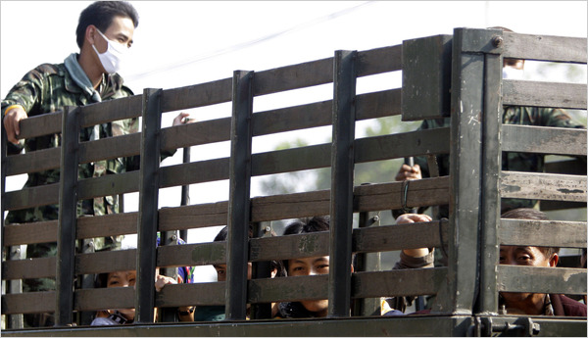
Sakchai Lalit/Associated Press
Hmong refugees leaving their refugee camp in Phetchabun Province on Monday morning.
BANGKOK — Armed with riot shields and batons, Thai military officers began early on Monday to forcibly return 4,000 Hmong asylum seekers to Laos in a lingering echo of the Vietnam War.
A government spokesman, Panitan Wattanayagorn, said in a telephone interview that the repatriation had started and would be completed within days.
Members of a mountain tribe that aided the United States in its secret war in Laos, the asylum seekers have said they fear retribution by the Laotian government, which continues to battle a ragged insurgency of several hundred Hmong fighters.
Thailand moved ahead with the repatriation despite complaints from the United States, the United Nations, and human rights and aid groups. It was doing so although it has determined that some asylum seekers were eligible for refugee status, human rights groups said.
“This forced repatriation would place the refugees in serious danger of persecution at the hands of the Lao authorities, who to this day have not forgiven the Hmong for being dedicated allies of the United States during the Vietnam War,” Joel R. Charny, acting president of Refugees International, an advocacy group in Washington, said in a statement.
Close to 5,000 troops and security officers entered the Hmong camp at 5:30 a.m. and opened the operation by rounding up “potential troublemakers,” said Sunai Pasuk, the Thailand representative of Human Rights Watch. Reporters were not allowed inside, but there were no reports of resistance.
They were to be processed at a military headquarters, then bused across the Mekong River into Laos.
In advance of the eviction, the military removed residents’ mobile telephones and halted medical services and food provided by aid groups, apparently “to physically and mentally break their resistance to their deportation,” Mr. Sunai said.
“Such coercive, intimidating and brutal measures are clearly the opposite of the concept of ‘voluntary repatriation,’ ” he said.
The remote Hmong encampment in Phetchabun Province, about 200 miles north of Bangkok, is a remnant of an Indochinese refugee population that once numbered 1.5 million. That included boat people from Vietnam, survivors of the brutal Khmer Rouge government in Cambodia and hundreds of thousands of Hmong who crossed the Mekong River from Laos.
Since the war ended in 1975, the United States has processed and accepted about 150,000 Hmong refugees in Thailand for resettlement in the United States. But in the past three years Thailand has not allowed foreign governments or international agencies to interview the Hmong.
Refugee experts say the camp residents are a mix of refugees who fear persecution and economic migrants who have left Laos over the past few years. They have included dozens who display what appear to be battle scars, as well as some older refugees who fought on the American side during the war.
A separate group of 158 asylum seekers has been interviewed by the United Nations, which has labeled them “people of concern” who could face persecution if returned. But the Thai government says these asylum seekers will be forcibly repatriated eventually.
The government has said that the deportations will be completed by Thursday, under an agreement with Laos.
Mr. Panitan said Laos had said that the returnees would be treated well and that the United Nations could interview them within 30 days of arrival to determine if any were eligible for resettlement elsewhere. “There is no reason to believe that they will be harmed,” he said.
“We have been repatriating Laotian Hmong in the past few years,” he said. “I think this is the 19th time, and they seem to be fine. Their living conditions seem to be better when they return.”
Reporters have not been permitted into Hmong camps since 2007, and last May the main aid group assisting the Hmong in Phetchabun, Médecins Sans Frontières, withdrew from the camp in protest of the conditions there.
“We can no longer work in a camp where the military uses arbitrary imprisonment of influential leaders to pressure refugees into a ‘voluntary’ return to Laos, and forces our patients to pass through military checkpoints to access our clinic,” the group said.
Speaking by telephone from Washington on Sunday, Eric P. Schwartz, assistant secretary of state for population, refugees and migration, said that he had met with officials in Thailand last week and that the United States was prepared to assist both with questions of third-country asylum and with the return to Laos of economic migrants. He said Thailand had rejected this offer.
“We recognize the challenge of irregular migration that the government of Thailand faces, but there is absolutely no need to resort to these kinds of measures,” he said.
Copyright 2009 The New York Times Company

