April 18, 2008

Prominent Tibetan Figure Held by China, Friends Say
By ANDREW JACOBS
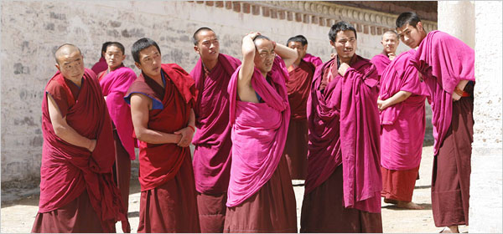
Reinhard Krause/Reuters
Tibetan monks at a monastery in Gansu Province, China, near Tibet, watched visiting journalists on an official tour last week.
BEIJING — The Chinese authorities have detained a prominent Tibetan television broadcaster and intellectual who is also a popular singer, suggesting that the government crackdown after the disturbances in and around Tibet has yet to run its course.
The reporter, Jamyang Kyi, 42, an announcer at the state-run television station in Qinghai, a western province bordering Tibet, was escorted from her office on April 1 by plainclothes police officers in the city of Xining, according to colleagues and friends. The authorities also confiscated her computer and a list of contacts, they said.
Her husband, Lamao Jia, who is also a journalist and a writer, said he had received no word from his wife for more than a week and did not know where she was being held. “She is in serious trouble,” he said in a telephone interview on Thursday. “I’m very worried for her safety. I’m very sorry. I can’t say more.”
There has been no official confirmation of the detention.
Although she has worked in the Tibetan-language division of Qinghai Television for two decades, Jamyang Kyi is better known for her singing and song-writing, especially among overseas Tibetans. She has traveled and lectured abroad, appearing with other Tibetan performers, some of them prominent exiles.
She is also a respected intellectual and blogger who has written about women’s rights and the trafficking of girls. Chukora Tsering, a researcher at the Tibetan Center for Human Rights and Democracy in Dharamsala, India, said he knew of nothing in her music or writings that might have provoked the authorities. “She is completely apolitical, but she is a proud Tibetan,” he said. “Still, given her background, we are not entirely surprised she has been detained.”
The Chinese government is always sensitive to public expression that could be construed as advocating Tibetan independence, but its vigilance has intensified since the outbreak of disturbances in Lhasa, the Tibetan capital, and in Tibetan-populated areas of China last month. The riots have been followed by a spate of protests and clashes in neighboring provinces that have large Tibetan populations. The atmosphere remains especially tense in Qinghai and Gansu Provinces.
According to Xinhua, China’s official news agency, 2,200 people, 519 of them monks, have been taken into custody since the riots began in mid-March. The agency said 1,870 of those had been released after questioning, but officials are still seeking scores of people who took part in disturbances that the government contends killed 19 people, nearly all of them Han Chinese. Tibetan exiles put the figure at 140 and say most of the dead were Tibetan.
In recent weeks, the government-run media have featured a steady diet of articles detailing the crimes of “Tibetan separatists” who they say are being led by the Dalai Lama. On Wednesday, the police said they discovered dynamite, weapons and satellite dishes at 11 Tibetan Buddhist monasteries in Gansu, in northwestern China.
And on Thursday, Xinhua featured the confessions of two “riotous monks,” Garzang Samdain and Garzang Samzhou, who it said had admitted to setting fire to a government building in Gansu, tearing up the Chinese flag and holding aloft the Tibetan flag, which is banned in China. Last weekend the police posted photographs on the Internet of 14 Tibetans being sought for questioning.
Jamyang Kyi has avoided themes or language in her music and writings that could be construed as challenging the Communist Party’s hold over Tibet. Many ethnic Tibetans complain of government policies they say favor Chinese culture over the traditional religion and language of Tibet, an accusation Chinese officials deny.
“I’m 99 percent sure that there is no basis for the accusations against her, whatever they might be,” said Robert Barnett, director of Columbia University’s Modern Tibetan studies program, a sponsor of her two-month visit in 2006, during which she gave lectures about Tibetan-language journalism and culture.
Asked about Jamyang Kyi’s detention, Jiang Yu, a Foreign Ministry spokeswoman, said she was unaware of the songwriter’s case. She insisted, however, that the Chinese legal system dealt fairly with all its citizens. “China is a country under the rule of law,” she said when asked about Jamyang Kyi on Thursday. “The law protects freedom of speech and other rights of its citizens. Only when a person goes against the law will they be punished by the law.”
Copyright 2008 The New York Times Company

