East Timor extends state of emergency
- Ian Mackinnon
- guardian.co.uk,
- Wednesday February 13 2008

About this article
Close
This article was first published on guardian.co.uk on Wednesday February 13 2008. It was last updated at 12:17 on February 13 2008.
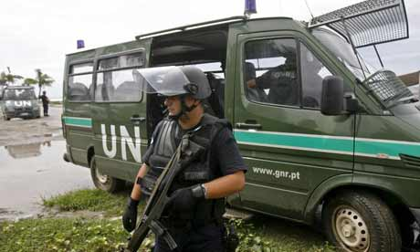
Portuguese soldiers on the streets of Dili. Photograph: Made Nagi/EPA
East Timor's parliament today extended for another 10 days the state of emergency declared after abortive assassination attempts against the island nation's president and prime minster.
Also today, prosecutors announced they would to issue 18 arrest warrants for those suspected of involvement the attacks.
The request for the extension was made by the prime minister, Xanana Gusmao, who was unhurt in the attack which left the president, Jose Ramos-Horta in a medically-induced coma recovering from two gunshot wounds.
Surgeons in Australia who carried out further operations to remove bullet fragments at a Darwin hospital said the 58-year-old Nobel peace prize winner was expected to make a full recovery and could be home within three weeks.
An uneasy calm prevailed in the East Timorese capital, Dili, which remains under dusk-to-dawn curfew and a heavy security presence of international troops and UN police, whose numbers have been reinforced by an another 200.
But as the body of the rebel soldier, Alfredo Reinado, killed in the exchange of gunfire with the presidential bodyguard, was handed back to his family for burial tomorrow, a crowd of about 500 supporters gathered at his home.
UN police provided tight security at the house and the throng remained peaceful, even as the coffin lid was raised several times to check that it was indeed Reinado. But the Reinado followers - some weeping and shouting "Viva Alfredo" - underscored the potential for trouble in violence-racked former Portuguese colony.
Reinado, a former major in the military police who mutinied with 600 soldiers in 2006, led two car loads of rebels against Ramos-Horta's official residence in a dawn attack. An hour later the convoy of Gusmao, 61, was ambushed in what the prime minister described as a failed "attempted coup".
Prosecutor-general Longuinhos Monteiro said investigations had thrown up the names of 18 accused, presumed to be renegade soldiers. All fled into the jungle after the attacks and there have been no arrests.
Amnesty International said the assassination attempts showed that a "culture of impunity" was destabilising East Timor after Ramos-Horta called off a manhunt for Reinado, wanted for murder charges, hoping instead to negotiate with the rebel leader.
guardian.co.uk © Guardian News and Media Limited 2008

