Genocide Education for Prevention at Ryerson University
By Armen Karo Student Association
Thursday, 25 March 2010

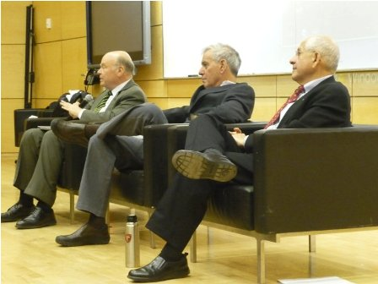

Toronto - More than 200 were in attendance at the colloquium organized by the Armenian Students’ Association at Ryerson University. The colloquium was titled “Genocide and its Aftermath: Education for Prevention” and was organized on the occasion of the 95th Anniversary of the Armenian Genocide. The event took place on Thursday, March 18 and materialized with the support of the Ryerson University Administration and Staff, who were determined to hold the event as a response to Ryerson University’s inadvertent participation in an event featuring Armenian Genocide denial on campus last year which was cosponsored by the Federation of Turkish Canadian Associations.

The participating academics were Dr. Gregory Stanton, Dr. Yair Auron, and Dr. Frank Chalk, all of whom delivered important messages on genocide recognition, prevention and denial. Stanton spoke about the methods used by perpetrators in denying genocide and made references to how the Turkish Government employs them in Turkey and abroad. Auron discussed the State of Israel’s unwillingness to recognize the Armenian Genocide and the irony of genocide denial by a state whose people suffered the same fate. He outlined the many occasions were the Jewish people referenced the Armenian Genocide and used stories of Armenian resistance, such as Musa Dagh, as a source of inspiration during the genocide of the Jews, and showed disappointment toward the modern day denial practiced by Israel for the sake of personal interests. Chalk gave the audience insight into tools and methods at our disposal with which states can act as watchdogs and help prevent cases of genocide. Through his discussion on the Will to Intervene, Chalk expressed concern about humanity’s continued failure in preventing genocides, despite increased knowledge and understanding on the matter. He highlighted Canada’s continued commitment to execute the Responsibility to Protect as a means to preventing future cases of genocide.

The audience had the opportunity to ask questions to the panel after the lectures. Interesting discussions took place on the Turkish Prime Minister’s recent threats to deport Armenians living in Turkey, recent Turkish denialist behaviour in light of recognition by the Foreign Affairs Committee of the U.S. House of Representatives and the Swedish parliament, and on the issue of reparations. The Turkish Government and its affiliates will unfortunately continue to operate their denial machine internationally, but will fail to achieve their goals, as long as our academic institutions dedicate the time and resources, as Ryerson University did with this lecture, to educate and spread awareness about the harms of genocide denial and the consequences of our failure to prevent future cases of genocide.

