Hrant Dink Lawyer Found Hanged (Updated)
By Weekly Staff, Asbarez News
4 June 2010
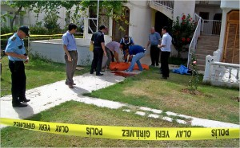
A Catholic bishop was stabbed to death in Southern Turkey on June 3.
ISTANBUL, Turkey (A.W.)–While attention in Turkey is directed towards Israel and the Flotilla attack, Hakan Karadag, one of the lawyers of Turkish Armenian journalist Hrant Dink’s murder case, was found hanged in his apartment in Cihangir, Istanbul, on June 4. His body was taken for autopsy. Police has not released a report yet on the cause of his death.
During one of the latest hearings of the trial, defendant Ogun Samast, who killed Dink on Jan. 19, 2007, wrote something on a piece of paper. The judge asked for the paper. On it, Samast had scribbled Karadag’s name. Also, according to Today’s Zaman, Samast had told Karadag in court: “You better visit the prison one day,” with a threatening tone. Karadag filed an official complaint with the judge. Samast objected saying he had no intention to threaten him, explaining that he only asked Karadag not to insult him.
In their statements to the press, relatives of Karadag said that the lawyer could not have committed suicide, and that he “did not have such issues.”
A day earlier, a Roman Catholic bishop, Luigi Padovese, was stabbed to death by his driver in Iskerderun, a port on the Mediterranean.

