Turkey Cries ‘Preconditions’ in Response to Court Ruling
by Asbarez Staff
16 January 2010

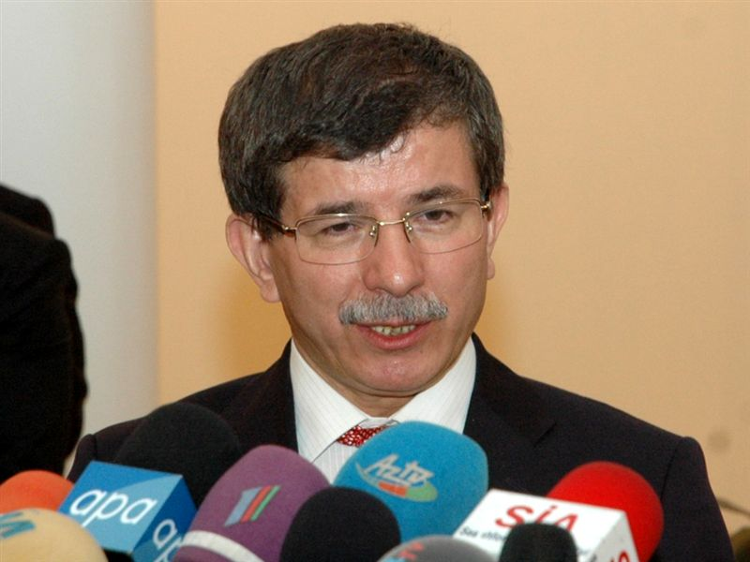
Turkish Foreign Minister Ahmet Davutoglu

ANKARA, YEREVAN (Combined Sources)—In response to last week’s ruling by Armenia’s Constitutional Court, the Turkish Foreign Ministry Tuesday issued an announcement condemning Armenia for setting “unacceptable” preconditions on the Armenia-Turkey protocols.

In a statement issued late Monday, Turkey’s foreign ministry said “It has been observed that this [Constitutional Court] decision contains preconditions and restrictive provisions which impair the letter and spirit of the Protocols.”

“The said decision undermines the very reason for negotiating these Protocols as well as their fundamental objective. This approach cannot be accepted on our part,” continued the Turkish statement.

“Turkey, in line with its accustomed allegiance to its international commitments, maintains its adherence to the primary provisions of these Protocols,” added the statement.
“We expect the same allegiance from the Armenian Government,” the Turkish Ministry said in a statement,” concluded the brief statement.

On January 12, Armenia’s Constitutional Court upheld the constitutionality of the protocols, adding however, that the documents cannot have any connection with the ongoing Nagorno-Karabakh conflict resolution process or impede Armenia of its pursuit of international recognition of the Armenia Genocide. To reinforce the latter point, the Court referenced Article 11 of Armenia’s Declaration of Independence, which states: “The Republic of Armenia stands in support of the task of achieving international recognition of the 1915 Genocide in Ottoman Turkey and Western Armenia.”

Official Yerevan was quick to react with Foreign Minister Eduard Nalbandian saying that he will personally phone his Turkish counterpart Ahmet Davutoglu to “express my bewilderment and clarify where exactly the Turkish side sees preconditions and just how the decision by Armenia’s Constitutional Court contradicts the fundamental objectives of the protocols.”

Nalbandian also suggested that the Turkish government was looking for excuses to delay the process and add further preconditions on the protocols.

Despite countless arguments by the Armenian President and foreign minister that Armenia has entered this process without preconditions, Turkey has repeatedly linked the normalization of relations between the two countries with the resolution of the Nagorno-Karabakh conflict in favor of Azerbaijan.

As recently as late last week, Turkish Prime Minister Recep Tayyip Erdogan said that the protocols would not be ratified until a resolution to the Karabakh conflict is reached. These remarks came after his meeting with Russian Prime Minister Vladimir Putin who bluntly said that the processes were separate and could not be interconnected. The same position was expressed by Russian Foreign Minister Sergei Lavrov last week during his official visit to Yerevan.

The Armenian Revolutionary Federation, which has spearheaded vocal opposition to the protocols both in Armenia and the Diaspora, rejected Turkey’s statement. The party’s political director Giro Manoyan told reporters Tuesday that with its statement Turkey proved, once again, that, aside from its own interpretations, it rejects any other explanation of the protocols.
Manoyan warned that after this announcement by Turkey, Armenian authorities should not attempt to weaken the Armenian high court’s position.

“It is imperative for the Armenian authorities to not seek to weaken the Armenian Constitutional Court’s decision,” said Manoyan explaining, “The Armenian government must continue the process in the spirit of the court ruling.”

In a statement issued by the ARF following the Court ruling, the party expressed its continued rejection of the protocols, but added that the Constitutional Court provisions referenced above provide an opportunity for revisions in the next phase of the ratification process.
“We have launched a process of normalization in relations with Armenia and in good faith taken steps that include the signing of the protocols,” Foreign Ministry spokesman Burak Ozugergin told the Hurriyet Daily News & Economic Review. “We have often expressed our views about what the necessary conditions are for the maintenance of peace and stability in the Caucasus.”

The Turkish government submitted the protocols to Parliament, but they have not been submitted for ratification because they depend on the progress in the Nagorno-Karabakh conflict, added Hurriyet in its news report on the matter.

Burcu Gultekin Punsmann, a Caucasus expert at the Turkish think tank TEPAV, said the diplomatic agreements were a product of consensus between the states concerned and argued that the Armenian constitutional court’s reasoning was putting limits on points for which the sides had already reached an agreement, reported the Hurriyet.

Copyright 2009 Azbarez Post

