http://www.hrw.org
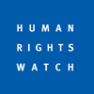

Human Rights Watch

US/China: Obama Should Raise Human Rights in China
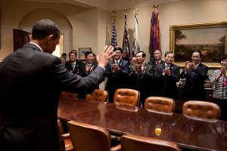
President Barack Obama bids farewell to Chinese Ministers in the White House after the first US-China Strategic and Economic Dialogue on July 28, 2009.
© 2009 Official White House Photo / Pete Souza

November 9, 2009
(New York) - United States President Barack Obama should raise key human rights concerns publicly on his first official visit to China, Human Rights Watch said in a letter released today.
"President Obama has spoken forcefully about the importance of defending human rights globally in speeches in Egypt, Ghana, Turkey, and at the United Nations," said Kenneth Roth, executive director of Human Rights Watch. "The test now is whether he will do so in a country where the government remains profoundly hostile to these concepts."
The letter urges Obama to raise three key issues, including:
- Freedom of expression, including internet censorship and the imprisonment of peaceful government critics;
- Rule of law, especially the disbarment of China's fledgling "rights protection" lawyers;
- Tibet and Xinjiang, particularly the executions of Tibetans alleged to have been involved in the March 2008 protests there, and of Uighurs for involvement in the July 2009 protests in that region.
The letter acknowledges some of the administration's steps to promote human rights in China, such as issuing a statement on the 20th anniversary of Tiananmen Square and raising some individual cases. But the lack of more visible, consistent action on human rights, coupled with Secretary Clinton's February 2009 comments en route to Beijing that human rights "shouldn't interfere" with other issues in the US-China relationship, and the decision not to meet the Dalai Lama prior to the November summit, has raised expectations within the Chinese government that Obama will not press these concerns.
"The Chinese government is now betting that President Obama won't raise human rights, while Chinese civil society activists, lawyers, and peaceful critics - the kind of people with whom the President typically aligns himself - are fervently hoping he will," said Kenneth Roth.
© Copyright 2009 Human Rights Watch

