Yemen car bomb blast leaves 25 dead

By Associated Press, The Guardian

25 February 2012
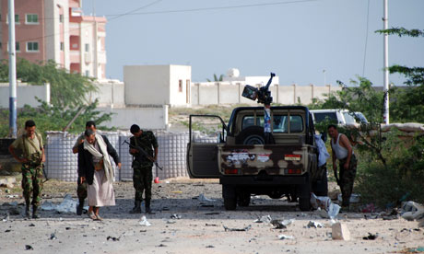
Credit: AFP/Getty Images
Yemeni security guards inspect the road outside presidential palace in Mukalla where a suicide bomber blew up a vehicle killing 25 people.

At least 25 people were killed in a car bomb attack outside the gate of a presidential compound in Mukalla, south Yemen, hours after the country's new president Abed Rabbo Mansour Hadi was sworn in and vowed to fight al-Qaida.
The attack was carried out by a suicide bomber and bore the hallmarks of an al-Qaida operation, a security official said. Both al-Qaida and southern separatists are active in the region.
Hadi has replaced longtime leader Ali Abdullah Saleh, following an election aimed at ending more than a year of political turmoil in Yemen. Hadi was the only candidate in the election.
In his televised speech before parliament, Hadi vowed to keep up Yemen's fight against al-Qaida-linked militants, who have seized control of towns and swathes of territory in the country's restive south.
"One of the most prominent tasks is the continuation of war against al-Qaida as a religious and national duty, and to bring back displaced people to their villages and towns," Hadi said.
Hours after his speech, the blast rocked Mukalla, in the province of Hadramout, part of formerly independent south Yemen, which united with the north in 1990.
Ahmed al-Rammah, an eyewitness , said he saw a pickup moving slowly to the gate as soldiers were coming out. "Then it exploded," he said.
Hadramout's governor, Khaled Said el-Deeny, said that police have launched an investigation. The province is one of many in southern Yemen that has been wrecked by violence in the wake of anti-Saleh protests over the past year. Many accuse Saleh of allowing security to collapse as a way of pressuring western governments and neighbouring Gulf countries into keeping him in power.
Copyright 2012 The Guardian

