Yemeni soldiers' death toll rises after al-Qaida assault

By Associated Press, The Guardian

6 March 2012
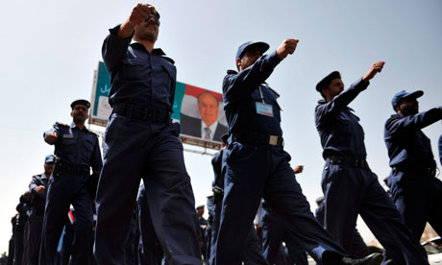
Credit: Yahya Arhab/EPA
Yemeni soldiers march past a picture of the new president, Abed Rabbo Mansour Hadi. Photograph:

The death toll from an al-Qaida assault on a military base in southern Yemen has risen to 185 government soldiers, military and medical officials say. Many soldiers' bodies were found mutilated and some were headless.
The scale of the army's defeat in Sunday's battle, which appears to be the worst ever suffered by Yemen's military in its 10-month campaign against al-Qaida in the southern province of Abyan, deals a major blow to efforts by the newly inaugurated Yemeni president, Abed Rabbo Mansour Hadi, to uproot the militant movement from the region.
The surprise attack and the mutilations have left government troops fearful and with low morale, according to a senior military official who was part of the defeated force. Another 55 soldiers were captured and paraded through a nearby town by the militants, who lost 32 of their fighters in the assault.
Medical officials in the area confirmed the latest death toll and said some of the bodies of soldiers recovered were missing their heads and bore multiple stab wounds. They said the military hospital morgue was packed with bodies, and some were taken to vegetable freezers in a military compound for lack of space.
A senior military official said the attack left his soldiers "fearful of al-Qaida because of the barbarism and brutality of their attack".
"Al-Qaida managed to deal a blow to the army's morale. Imagine how soldiers feel when they see the bodies of their comrades dumped in the desert," he said.
Military officials had earlier said militants overran the base and captured armoured vehicles and artillery pieces, which they turned on the army.
The official said the soldiers were taken unawares. "It was a massacre and it came by surprise as the soldiers were asleep," he said. Militants sneaked behind army lines and attacked from the rear where there was "zero surveillance".
The attack appeared to be a response to a pledge by Hadi to fight the Yemeni branch of al-Qaida, believed to be the most active of the militant movement's subsidiary networks.
Hadi took over last month from the longtime ruler, Ali Abdullah Saleh, as part of a power-transfer deal backed by the US and initiated by Arab Gulf countries.
The year-long uprising against Saleh had caused a deterioration of central state authority throughout the country, and allowed al-Qaida to seize Zinjibar in May and fight off repeated army offensives to retake it.
The US had hoped that replacing Saleh would take some pressure off Yemen's government and military, who also confront tribal and separatist insurgencies, and allow them to fight back more effectively against the militants.
Despite the defeat, and a surge of other attacks by al-Qaida, Hadi has continued to pledge to fight the militants. "The confrontation will continue until we are rid of the last terrorist, whether in Abyan or elsewhere," the Yemeni media quoted him as saying on Monday.
But he may not yet have the means at his disposal to do so: the military official in Zinjibar said the forces routed by al-Qaida were poorly equipped, and that better-trained, better-armed specialised anti-terrorist units needed to be brought to the front.
All officials spoke on condition of anonymity because of military protocol or because they were not allowed to speak to the media.
Copyright 2012 The Guardian

