Genocide and politicide warning: Yemen
By Genocide Watch
1 March 2012, updated 25 April 2012

On 22 May 1990 the Republic of Yemen was founded, unifying the Yemen Arab Republic (North Yemen) and the Marxist People's Democratic Republic of Yemen (South Yemen). The former president of the North, Ali Abdullah Saleh, became the first president of Yemen, although, he lacked support in the South. The political divisions between the former two countries were so overwhelming that in 1994 a civil war broke out. The secessionist southerners were defeated and the civil war aggravated the subordination of the south.

Yemen is the poorest country in the Arab world. Its UNDP human development index stands at 0.462, whereby Yemen ranks 154 out of 187 countries in the world. The country is thorn by three security issues: the separatist insurgency in the South, the Zaida Shia rebellion in the North (the Houthis) –supported by Iran through arm supplies– and the increasing presence of Al Qaeda. In addition, Yemen has to deal with Somali refugees, including Al Shabaab militants. Yemen has been called "a failed state" due to its divisions.

In January 2011, Yemen joined by the popular uprisings called "the Arab Spring". The desire for democratic change resulted in peaceful demonstrations by Yemeni citizens, which were violently repressed by government forces. According to a report by Human Rights Watch, at least 270 people, 120 in Taizz alone, died during the protests. Government officials have recently admitted that in fact over 2,000 Yemenis died. Although Yemen seemed to be a hopeless candidate for democracy, non-violent democratic protests continued. The fact that one third of the Nobel Peace Prize for 2011 was awarded to Tawakkol Karman, along with two other women leaders, encouraged the movement. It was an important symbolic victory for the voices of the Arab Spring, as well as for the role of women in the transition to peace and democracy. Symbols matter. They are how people think.

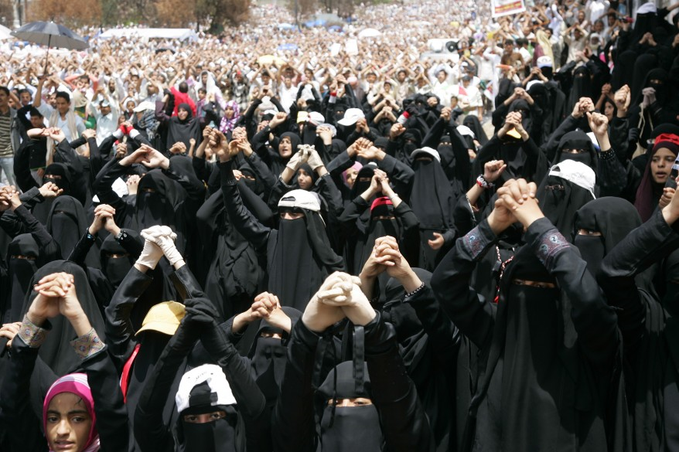
On November 23, President Saleh eventually agreed to transfer his power to Vice-President Abdu Rabbu Mansour Hadi in return for immunity from prosecution. Vice-President Hadi is known for his compromising nature. The Yemeni Parliament passed the necessary legislation in January. On February 25, 2012 President Hadi was sworn in before the Parliament. Two days later a ceremony took place which was attended by former president Saleh.

The transition to greater democracy in Yemeni politics has had many shortcomings. Only one candidate ran in the first Presidential elections and the family of former president Saleh still controls the security sector of Yemen, in particular the army and the security agencies. Recently, there have been rallies denouncing the dominant presence of former president Saleh's loyalists in the armed forces. However, President Hadi will guide the democratic transition in Yemen for two years. The challenges facing Yemen remain very high and necessitate a strong central government. The threat of Al Qaeda was evidenced again by a lethal bombing the day of President Hadi's swearing-in.
Credit: Reuters (17 June 2011)

Genocide Watch has downgraded the risk of genocide and politicide in Yemen from stage 7 (active massacres) to stage 6: potential massacres. Genocide Watch welcomes the recent transfer of power in Yemen and the large participation in elections by Yemeni citizens. However, the following risk factors are evidence that the security situation in Yemen is still of great concern. The roots of national identity and democracy are shallow. Yemen could again degenerate quickly into violence.
- There is still a governing elite in Yemen, dominated by Sunni Muslims. The government has to overcome this polarization by effectively incorporating and pacifying Shi'ite rebels in the north and the separatist movement in the south. The National Dialogue planned by President Hadi needs to represent members of these other communities.
- The Yemeni government is incapable of governing some remote areas in the country that are characterized by tribal animosity, kidnappings, brigandage and anarchy. Al Qaeda has a strong foothold in those regions and hundreds of soldiers have died during clashes since the new president took office.
- The Security Sector of Yemen needs urgent reform. In several cities there are still scattered command groups under military, paramilitary or tribal leadership, despite their connection to former president Saleh and the human rights violations they committed during the Arab Spring.
- Food shortages have increased insecurity in Yemen.
Relevant information should be sent to Yemen@genocidewatch.org.

